Profile of Dr Huma Javed Subzposh 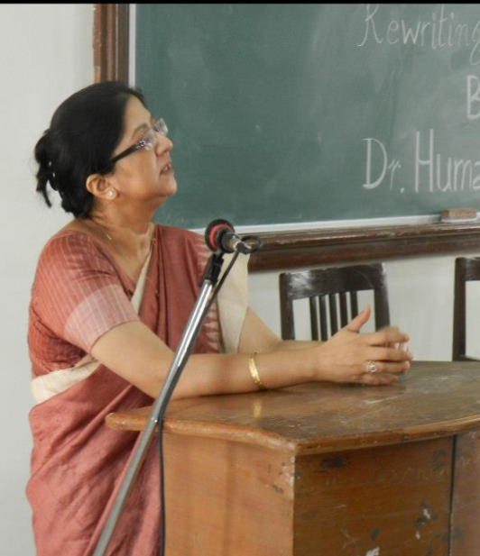

**Name:** Prof. Huma Javed Subzposh

**Date of Birth:** 28/01/1966

**Academic Qualification:** D.Litt in English

**No. of Years of Service:** 30 years, 4 months and 20 days as on 15/09/2017

**Current Designation:** Professor of English, DDU Gorakhpur University, Gorakhpur

**Date of Last Promotion:** 13/12/2009

**Publications:**

**Books:**

1. *The Disintegrating Psyche: A Study of Jean Rhys’s Marginalized Heroines,* Classical Publications, New Delhi: 2003.
2. *Literatures of South Asia. (*ed.), ABS Books, New Delhi: 2016.

**Research Papers:**

1. “The Legacy of Diaspora in Jhumpa Lahiri’s *Interpreter of Maladies*”, *Papers on Contemporary British and American Literature: Dynamics of Culture,* 2002.
2. “The Issues of Mothers and Motherland in the Novels of Jean Rhys”, *Lucknow Journal of English Studies,* July 2002, pp.67-75.
3. “The Empire Writes Back: *The Tempest* and Marina Warner’s *Indigo*”, *Papers on Postcolonial Literature and Theory*, 2003, pp. 57-63.
4. “Autobiographical Elements and the Trauma of Inherited Diaspora in Jhumpa Lahiri’s *The Namesake*”, *Papers on Indian Literature in English after 1980*, 2005, pp. 28-32 .
5. “The Legacy of Diaspora in Jhumpa Lahiri’s Works”, *The SPIEL Journal of English Studies*, Lucknow, January 2006, pp. 53-60.
6. “Patriarchy and Talibani Dictat: Women as Subaltern in Khaled Husseini’s *A Thousand Splendid Suns*” in South Asian Literatures, (ed. By Subzposh, Huma Javed et al.) ABS Books, New Delhi: 2016, pp. 103-115.

**Details of Research Supervision:**

**Ph.D. Awarded:**

1. Dr Anita Chaurasia for her dissertation ‘Social Criticism in the Novels of E.M.Forster’
2. Dr Akhlaque Ahmad for ‘A Reassessment of Hardy’s Feminism in the Modern Context’.

**Research in Progress:**

1. ‘The Legacy of Diaspora in Jhumpa Lahiri’s Fiction” by Km. Neha.

**Seminars Attended and Papers Read:**

1. Attended the National Seminar on ‘Contemporary British and American Fiction: The Dynamics of Culture’ organised by the Department of English, D.D.U. Gorakhpur University, Gorakhpur on December 2, 2001, and read a paper entitled “The Legacy of Diaspora in Jhumpa Lahiri’s *Interpreter of Maladies*”.
2. Attended the All India English Teachers’ Conference at Lucknow on December 27-29, 2002, and presented a paper entitled “*Jane Eyre* to *Wild Sargasso Sea*: The Shift inPerspective*”.*
3. Attended the National Seminar on ‘Postcolonial Literature and Theory’ organised by the Department of English, D.D.U. Gorakhpur University, Gorakhpur on March 8-9, 2003, and read a paper entitled ‘The Empire Writes Back: *The Tempest* and Marina Warner’s *Indigo*”.
4. Attended the National Seminar on ‘Marginal Existence: New Trends in Literature’ organised by the Department of English, D.S.B. Campus, Kumaon University on November 4-6, 2004, and read a paper entitled “Post Colonial Discourse and Rewriting of the Canon”.
5. Attended the National Seminar on ‘Indian Writing in English After 1980’ organised by the Department of English, D.D.U. Gorakhpur University, Gorakhpur on February 26-27, 2005, and read a paper entitled “Autobiographical Elements and Inherited Diaspora in Jhumpa Lahiri’s *The Namesake*”.
6. Attended the National Seminar on ‘Marginality and Post colonialism’ organized by the Department of English and Modern European Languages, Lucknow University, Lucknow on October 17-18, 2007, and read a paper entitled “Postcolonial Texts and Contexts”.
7. Attended the U.G.C. National Seminar on ‘Global Literatures, National Identity and the Subaltern: Emerging Trends in English Writing’ organized by the Department of English, D.D.U. Gorakhpur University, Gorakhpur on February 11-12, 2009, and presented a paper entitled “Patriarchy and the Talibani Diktat: Women as Subaltern in Khalid Husseini’s *A Thousand Splendid Suns*”.
8. Attended the National Seminar on ‘SAARC Literatures in English’, organized by the Department of English and Modern European Languages, Lucknow University, Lucknow on February 18-19, 2009, and read a paper entitled “Patriarchy and Female Bonding: Feminist Discourse in Khalid Husseini’s *A Thousand Splendid Suns*”.
9. Attended the international seminar on ‘Imagining India: the Discourse of the Nation’, organised by the Department of English, Banaras Hindu University, Varanasi, on 18-19th December 2009 and read a paper entitled “India in Retrospect: Nostalgia and Reality in Jhumpa Lahiri’s *Unaccustomed Earth”.*
10. Attended the International Conference on ‘Literature, Language and Communication: An Essential Trident’ organised by Amity School of Languages, Lucknow on 9th and 10th December 2013 and presented a paper entitled “Rewriting Shakespeare: Recent Responses to Shakespearean Themes”.
11. Convened the UGC sponsored two-day National Seminar on Literature and Culture of South Asia organized by the Department of English, DDU Gorakhpur University, Gorakhpur on on Feb. 28 and March 1, 2014.
12. Attended UGC sponsored National Conference on ‘Literature: The socio-Cultural Milieu’ organized by the Department of english, St. Andrew’s College, Gorakhpur on October 17-18, 2014 and chaired a session.
13. Attended UGC sponsored National Seminar on ‘Fifty Years of Cultural Studies: Promise, Euphoria and After’ organized by the Department of English, DDU Gorakhpur University, Gorakhpur, on March 11-12, 2016, chaired a session and also presented a paper entitled “Postcolonial Discourse in J M Coetzee’s *Foe*”.

**Lectures Delivered:**

1. Four lectures in the 8th Refresher Course in English organised by Dr. Sushmita Bhattacharya in 2008, in the Academic Staff College, D.D.U. Gorakhpur University, Gorakhpur on Jhumpa Lahiri’s writings.
2. Six lectures in Refresher Course in English organised by Prof. S.Z.H. Abidi in March 2009, in the Academic Staff College, Lucknow University, Lucknow on the rewriting of the canon.
3. Two lectures in the 10th Refresher Course in English, jointly organised by Dr. Sunita Murmu and Dr. Alok Kumar in the Academic Staff College, D.D.U. Gorakhpur University, Gorakhpur on the common issues in Indian English and Urdu writings.
4. One extended lecture on Postcolonialism delivered in the Department of English, Daulat Ram Post Graduate College for Women, Delhi University, New Delhi, on 19th November 2012.
5. Two lectures in 11th Refresher Course in English organized by Dr G H Behera in the Academic Staff College, D.D.U. Gorakhpur University, Gorakhpur from Jan. 24 to Feb. 13, 2014.

**Academic Achievements:**

1. Qualified for UGC NET JRF in 1986.
2. *The Disintegrating Psyche* was added to the collection of seven international libraries, among them the library of the University of Newcastle and the reference section of the British Library in London in UK, the Park Library in the Iowa State University, the Howard-Tilton Memorial Library in Tulane University in New Orleans and Alibris in the US and the libraries of the state universities of Bremen and Gottingen in Germany. The link to the pages is <http://www.worldcat.org/identities/lccn-nb2003-78522> for details.
3. Awarded D.Litt for the thesis entitled “Texts Contexts and Con-Texts: Postmodern, Postcolonial and Feminist Rewritings of the Canon” under the supervision of Prof. S.Z.H. Abidi by The Department of English and MEL, Lucknow University, Lucknow on 11.11.2015.

**Contribution to Corporate Life:**

1. Served as member of the Executive Council, Academic Council, University Court, Examination Committee, Board of Studies etc. at various times.
2. Organised the 9th Refresher Course in English on “Global Issues in Contemporary English Literatures” from 29th January 2009-18th February 2009.
3. Convened a UGC sponsored National Seminar on “Literature and Culture of South-Asia” on 28th February and 1st March 2014.