**Dr.S.K.Tiwari,**

**Deptt. of Zoology, DDU Gorakhpur University, Gorakhpur**

**M.Sc. IV Semester Zoology (Entomology): Paper III (4103) Economic Entomology**

**­­­­­­­­­­­­­­­­­­­­­­­­­­­­­­ -----------------------------------------------------------------------------------------------**

**III. *Emmalocera depressella* (Sugarcane Root Borer)**

Order: Lepidoptera

Family: Pyraustidae

**1.Distribution.** The sugarcane root borer is distributed mainly in north India, viz., Uttar Pradesh, Bihar and Madhya Pradesh. However, at a lower scale it is found throughout in India and Pakistan (Fig. 1).

**2.Host plants.** The main host is sugarcane but it also infests maize, sorghum, millets munja.

**3. Appearance.** The head of the adult moth is pale-pink while wings are pale or dirty brown. It is about 20 mm across the wings. Its hind wings are larger in width than forewings. It has a dark lengthwise strip on each wing. The abdominal tip of the male is tapering while that of female is cylindrical.

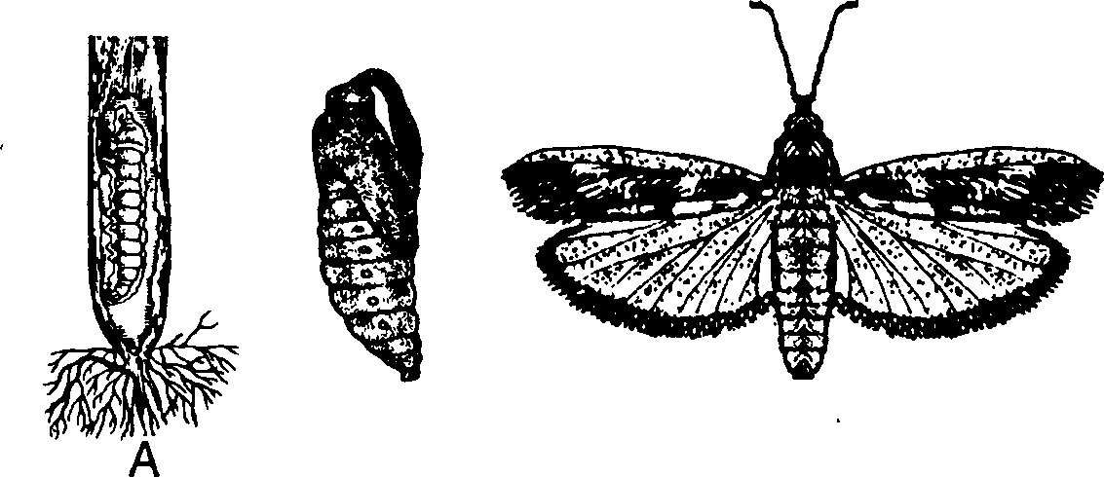

B

c

Fig 1. The sugarcane root borer, *Emmalocera depressella.*

(A) Larva in situ (B) Pupa (C) Adult female.

**4.**L**ife cycle.** The female deposits 200-300 eggs, singly or in batches on the under surface of the leaves. The eggs may be laid on stems or even on the ground. The eggs are creamy oval and scale-like.The eggs hatch after 4-7 days and soon after emergence, the first instar larva bores into the base of the shoot or below the soil surface. By their biting and chewing type of mouth parts the caterpillar cuts across the stem resulting into the formation of dead hearts.

The larval period is about 35-45 days during which the larva attains a maximum growth of 25-30 mm. Before attaining pupation period, the full-grown larva moves above the soil surface in the stem and makes an exit hole and constructs a silken tube in which it pupates.

After a pupation period of 9-14 days the moth emerges through the hole made previously by the larva. The entire life cycle takes about two months to complete. The last instar larvae of fifth generation undergo diapause to pass winter.

**5.Damage.** The caterpillars feed on the stem below the soil surface of the newly sprung shoot of the sugarcane from April to June. It results into the formation of dead-hearts. Thus the young canes die and the older ones dry and falls down. Its infection causes severe reduction in sugarcane yield as well as in reduction of sucrose content.

**6.Control measures:**

1. The infested plants should be stripped off.
2. In infested areas, ratoon crops should be dropped.
3. Resistant varieties of sugarcanes i.e. CO513 and CO313 should be planted in infested areas.
4. After harvesting, the part of the infected cane under soil should be collected and burnt to destroy the diapausing caterpillars.
5. The moths should be light trapped and destroyed.
6. The soil may be treated with endosulfan @ 30 kg/ha.
7. Soil application of carbofuran at 2 kg a.i ./ha or phorate at 1 kg a.i./ha is also recommended.
8. **Biological Control:** The larval parasitoids, *Goniozus* sp. (Hymenoptera:Bethylidae) and *Neohybothorax* sp.(Hymenoptera:Chalcididae) and egg parasitoid, *Trichogramma chilonis* (Hymenoptera:Trichogrammatidae) were recorded attacking *E. depressella* in India. The fungi *Beauveria* and *Metarhizium anisopliae* were observed attacking hibernating larvae.

-----------------------------------------o------------------------------------