**Dr.S.K.Tiwari,**

**Deptt. of Zoology, DDU Gorakhpur University, Gorakhpur**

**M.Sc. IV Semester Zoology (Entomology): Paper III (4103) Economic Entomology**

**­V. *Aleurolobus barodensis***

**Sugarcane Whitefly**

Order: Hemiptera

Family: Aleyrodidae

1. **Distribution:** The sugarcane whitefly, *Aleurolobus barodensis* has assumed serious pest on sugarcane in Bihar, Gujarat, Haryana, West Bengal, Orissa, Karnataka, Maharastra, Punjab, Tamil Nadu, Uttar Pradesh, Uttaranchal and Andhra Pradesh (Fig. 1).
2. **Host plants:** The main host plant of this whitefly is sugarcane, however, it may feed on *Saccharum moonja,* wheat, barley and wild grasses.
3. **General Appearance**: The adult insects are small, 3.0 mm in length, fragile and pale yellow in colour. The female is bigger and stouter than male and sluggish in nature. They copulate just after emergence.
4. **Life cycle:** During November to December, the females lay nearly 65 creamy-white conical eggs on under surface of the leaf in a linear fashion close to the mid rib. The incubation period lasts after 5-7 days and the eggs hatch into small nymphs.

Nymphs are oval in shape and pale yellow in colour with three pairs of legs. The young nymphs (0.36 mm) take position on the under surface of the leaves and begin to suck the plant juice. During development, the nymphs undergo four moultings to attain adulthood. Three consecutive nymphal instars take about 25 days but the last instar needs 10-15 days.

The last instar nymph undergoes pupation converting itself as a pseudopupa as true pupa arc not found in the life history of Hemiptera. After 8- 10 days, adults emerge out. The longevity of the adult is not more than 2 days. The

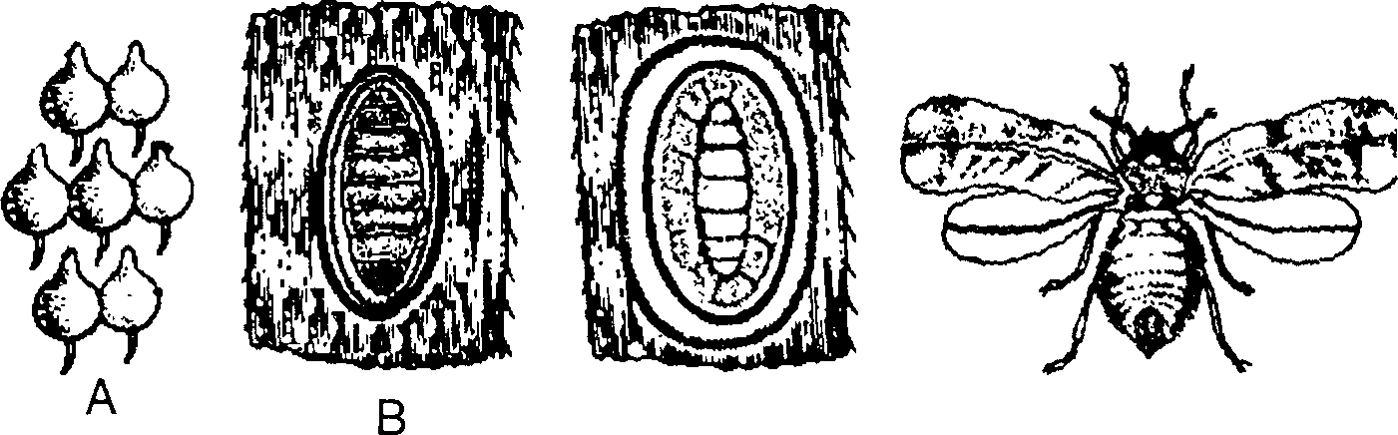

c

D

Fig. 1. The sugarcane whitefly, *Aleurolobus* *barodensis*

A. Eggs B. Nymph C. Pseudopupa D. Adult

entire life cycle completes within 25-48 days. Nine generations have been recorded in south India.

1. **Damage:** The nymphal stages damage the crop by sucking the plant sap of the leaves with the help of piercing and sucking mouthparts. In the month of July-November, they cause severe damage to ratoon crops. The plants turn pale in colour and the leaf apices remain unopened. The sugar content in cell sap decreases up to a great extent.
2. **Control measures:**  Nitrogen balance should be maintained in the soil. Infested leaves should be collected and destroyed. Ratoon crops should be avoided. Resistant varieties of sugarcane should be planted. Spraying of imidacloprid@ 0.3 ml/l along with 2% urea or azadirachtin @ 4g a.i./ha (0.0004%) at 5 ml/l or dimethoate@ 2 ml/l reduce the white fly population.

**Biological Control:** Several parasitoids that attack sweet potato white fly attack sugarcane whitefly also. These parasitoids are *Encarsia* and *Eretmocerus* etc*.* Many predators like bugs, ladybird beetles, ants, spiders and mites. Fungi *Verticillium lecanii, Paecilomyces fumosoroseus, P. farinosus* are pathogenic for whiteflies.

--------------------------------0----------------------------------