**Dr. S.K.Tiwari**

**Department of Zoology, DDU Gorakhpur University, Gorakhpur**

**B.Sc. II Year, Zoology Paper II- Vertibrate Zoology**

**____________________________________________________________________________**

**­­** **Biting or Poisonous Apparatus of a Poisonous Snake**

All the poisonoussnakes have poison apparatusin their head, which is not found in

non–poisonoussnakes. Poisonous apparatus of snakesinclude the following parts-

1. A pair of posion glands
2. A pair of poison ducts
3. Fangs (single in cobra)
4. Muscles
5. **Poison glands:**

**A paired sac-**like**poison glands**are situated on the either sides of the **upper jaw**. These are possibly modified super labial or parotid glands. The glands may be small and oval (**sea snakes**) or large and tubular (**vipers**) depending on species. Each gland is thickly encapsulated with fibrous connective tissue and mostly covered by a fan shaped constrictor muscle, often referred as temporal or masseter. Its stretching during biting squeezes poison from gland into its duct.

1. **Poison Ducts:**

A narrow**poison duct**leads anteriorly from each**poison gland**to the base of a**poison fang**to enter its**groove**or**canal**.

1. **Fangs :**

The **fangs are specialized**teeth attached to maxillary bones. They are long, curved, sharp and pointed**. They serve as hypodermic needles for injecting poison into the body of the victim. When a** functional fang is lost or damaged, it is replaced by one of the reserve fangs. On the basis of **structure**and**position three types of fangs** are found in poisonous snakes-

**(a) Proteroglyphous  fangs**:(protero, first)

**This** type of **fangs** are **small**, **grooved**and **permanently erect**at the **anterior**end of **maxillae**. Such **fang**is found in **cobras**, **kraits**, **coral snakes**and **sea snakes**.

**(b) Opisthoglyphous fangs**: (opistho, behind)

**In some poisonous snakes (family-Colubridae) fangs**are small, associated with the posterior end of maxillae and each grooved along its posterior border.

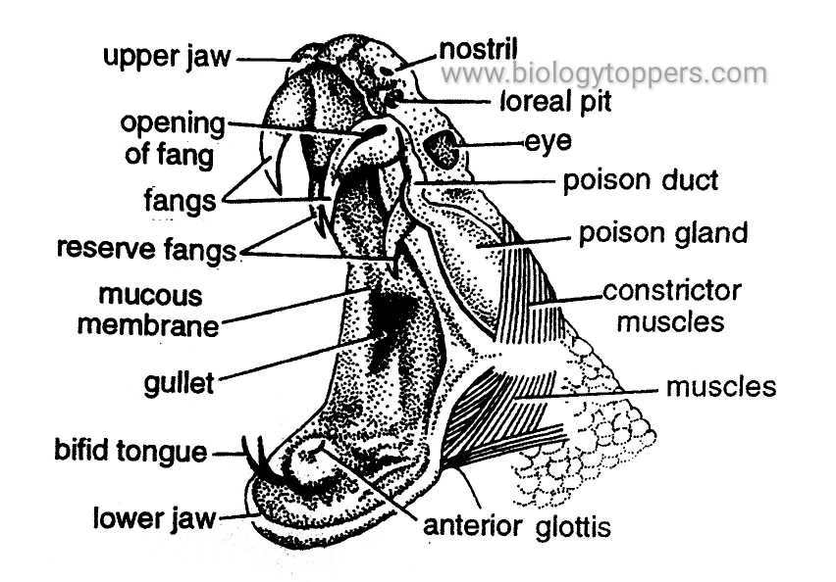

Fig.1. Head of rattle snake, *Crotallus* dissected to show poison apparatus

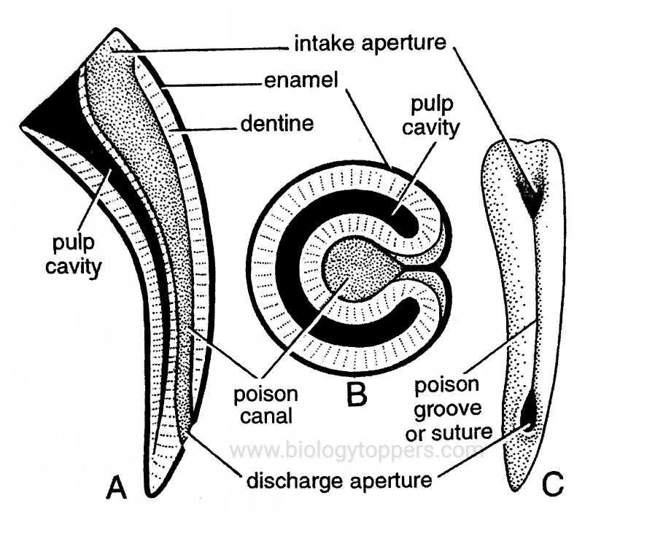

Fig. 2. **A.** Sonlenoglyphous fang in L.S. **B**. Sonlenoglyphous fang in T.S.

**C**. Entire grooved fang

**(c) Solenoglyphous** **fangs:**  (solen, pipe + glyph, hollowed)

**I**n vipers and rattle snakes, a pair of fangs occur, one on the front of each **maxilla**. Its base is covered by a sheath containing a few reserve and developing fangs. The fangs are movable and turned inside to lie close to the roof of mouth when it is closed. A hollow poison canal lined with enamel runs through the fang opening at the tip of the fang.

## Biting Mechanism of Snakes:

## Skull and jaw bones of poison snakes are very flexible and loosely articulated. **Mechanism** of biting involves two main purposes-

1. Erection of fangs and
2. Injection of poison into the victims body.

When a poisonous snake wants to strike, a series of movement of skull bones occur in a chain in the following way-

1. Contraction of digastrics muscles lowers mandibles so mouth opens.
2. and consequently quadrate is rotated forwar,
3. and hence it thrusts the pterygoid forward. This is also aided by the contraction of sphenopterygoid muscles.
4. Forward pull of pterygoid pushes the transverse or ectopterygoid upwards. This rotates the maxilla bearing fangs through 900 . Sothe fangs become vertically erect and in most effective position to strike.
5. A simultaneous stretching of constrictor muscles around the poison gland forces its poison through poison duct into the canal or groove of fang to be injected into the victim.
6. As soon as the prey comes into the mouth, mouth is closed by the contraction of temporal muscles, the above movements are reversed. The fangs embed in the prey and so venom is injected into the body of the prey. At the same time vertical fangs rotate to become horizontal.

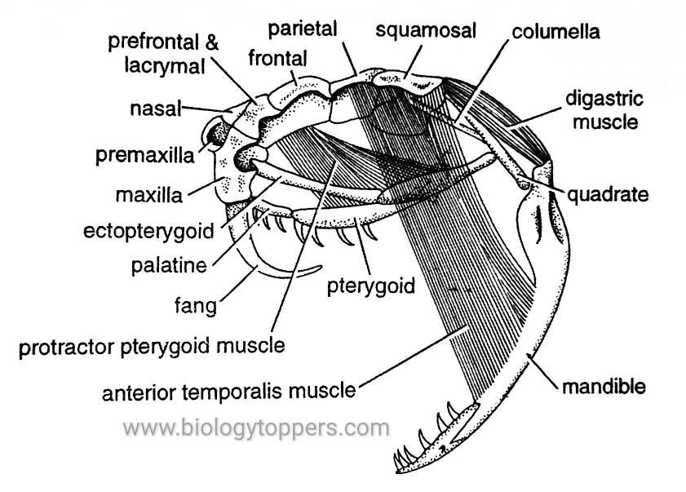 Fig. 3. Opened mouth of biting snake

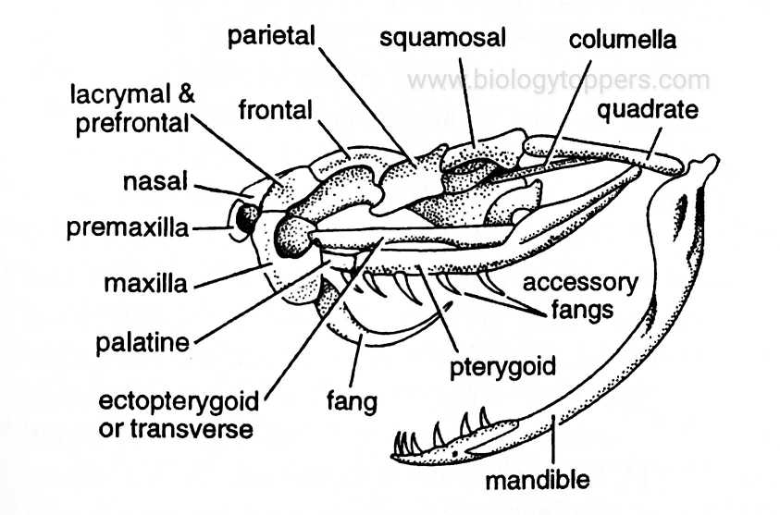

Fig. 4. Closed mouth of biting snake

.

**Snake venom:**

Snake venoms are complex mixtures of enzymatic and non-enzymatic proteins derived from modified [salivary glands](https://www.sciencedirect.com/topics/veterinary-science-and-veterinary-medicine/salivary-gland), snake venoms immobilize prey and predigest their tissue. [Hyaluronidase](https://www.sciencedirect.com/topics/pharmacology-toxicology-and-pharmaceutical-science/hyaluronidase) is present in most snake venom and works by catalyzing the cleavage of internal glycoside bonds and [mucopolysaccharides](https://www.sciencedirect.com/topics/pharmacology-toxicology-and-pharmaceutical-science/glycosaminoglycan). This action potentiates the activity of many of the other toxic agents. [Phospholipase A](https://www.sciencedirect.com/topics/pharmacology-toxicology-and-pharmaceutical-science/phospholipase-a), which causes hydrolytic breakdown of [membrane phospholipids](https://www.sciencedirect.com/topics/pharmacology-toxicology-and-pharmaceutical-science/membrane-phospholipid), is common to many snake venoms.This molecule displays cytotoxic, anticoagulant (prevents activation of clotting factors), and neurotoxic activities. [Collagenase](https://www.sciencedirect.com/topics/pharmacology-toxicology-and-pharmaceutical-science/collagenase) is also found in snake venom, leading to the digestion of collagen and breaking down of connective tissue.

Snake venoms are approximately 90% water and, in addition to enzymatic and nonenzymatic proteins, can contain lipids, carbohydrates, and [biogenic amines](https://www.sciencedirect.com/topics/pharmacology-toxicology-and-pharmaceutical-science/biogenic-amine). The actual toxins, which compose the “killing fraction,” are referred to as *venins*. The entire mixture is called *venom*.

**Antivenin:**

**Antivenin** also known as  **venom antiserum**, and **antivenom immunoglobulin**, is a specific treatment for [envenomation](https://en.wikipedia.org/wiki/Envenomation). It is composed of [antibodies](https://en.wikipedia.org/wiki/Antibodies) and used to treat certain [venomous](https://en.wikipedia.org/wiki/Venom_(poison)) bites. Antivenoms are recommended only if there is significant toxicity or a high risk of toxicity. The specific antivenom needed depends on the species involved.  It is given by injection.

Side effects may be severe. They include [serum sickness](https://en.wikipedia.org/wiki/Serum_sickness), [shortness of breath](https://en.wikipedia.org/wiki/Shortness_of_breath), and allergic reactions including [anaphylaxis](https://en.wikipedia.org/wiki/Anaphylaxis).  Antivenom is traditionally made by collecting venom from the relevant animal and injecting small amounts of it into a domestic animal. The antibodies that form are then collected from the domestic animal's blood and purified. Versions are available for [spider bites](https://en.wikipedia.org/wiki/Spider_bites), [snake bites](https://en.wikipedia.org/wiki/Snake_bites), [fish stings](https://en.wikipedia.org/wiki/Fish_stings), and [scorpion stings](https://en.wikipedia.org/wiki/Scorpion_stings). Due to the high cost of producing antibody-based antivenoms and their short shelf lives when not refrigerated, alternative methods of production of antivenoms are being actively explored.  One such different method of production involves production from bacteria. Another approach is to develop targeted drugs (which, unlike antibodies, are usually synthetic and easier to manufacture at scale). Antivenom was first developed in the late 19th century and came into common use in the 1950s. In listed in the [World Health Organization's List of Essential Medicines](https://en.wikipedia.org/wiki/WHO_Model_List_of_Essential_Medicines).

--------------------------o---------------------------