**Dr.S.K.Tiwari,**

**Deptt. of Zoology, DDU Gorakhpur University, Gorakhpur**

**M.Sc. IV Semester Zoology (Entomology): Paper III (4103) Economic Entomology**

**Biology of Honey Bee**

**Habitats of the Honey Bees:**

Honey bees require an ample supply of flowers in their habitat, since this is their food source. They also need suitable places to build hives. In cooler temperate climates, the hive site must be large enough for the bees and for storage of honey to feed on during the winter Researchers believe that the original habitats of the honey bee are tropical climates and heavily forested areas. Honey bees can thrive in natural or domesticated environments, though they prefer to live in gardens, woodlands, orchards, meadows and other areas where flowering plants are abundant. Within their natural habitat, honey bees build nests inside tree cavities and under edges if objects to hide themselves from predators.

**Life Cycle:**

Mating between queen and drone takes place in air during nuptial flight. A queen mates during the first 1-2 weeks of her adult life. She can take multiple mating flights and mated with several males – on average 12-15. Increasing the genetic diversity of the colony is important for colony productivity and disease resistance(Christina Grozinger, Pennsylvania State University).A queen may get mated several times (2-5) during successive flights. The drone after mating falls dead and the queen returns to the hive with a part of the aedeagus of male detached from the drone and retained in her sting chamber.

The queen lays about 1 .5 million of eggs during .her life of 4-5 years at the rate of about 350- 1 500 eggs/day. The inseminated queen lays both fertilised and unfertilised eggs singly in brood cells. The fertilised (diploid) eggs develop to daughters (future queen/workers) while unfertilised (haploid) eggs develop to sons (future drones) . This type of reproduction is known as arrhenotokous reproduction (Fig. 2).

Each egg is pinkish, elongated and cylindrical and attached to the bottom of the cell. The eggs hatch into small grubs after 2-3 days. All the grubs are fed with royal jelly for first two days by the nurse bees. The royal jelly is made up of digested honey and pollen mixed with secretion of maxillary gland. It is highly nutritious. The diploid grubs destined to be queen are fed with royal jelly throughout the larval period while those destined to be workers are fed·with only honey after third day. The haploid grubs destined to be drone are fed with nector and pollen after three days.

After 8 to 9 days of feeding the brood cells are sealed and the grubs undergo pupation . Before pupation the last instar grub spins a thin silken cocoon in which it pupates. The pupal period lasts for 8 to 14 days. The adult worker bees perform various works depending upon their age as mentioned above. Another queen is only produced when either the previous queen is died or the size of the colony becomes very large.

1. **Swarming**: The swarming is a process of leaving off the colony by the queen along with few drones and workers. In certain seasons of the year, usually from November to March, plenty of nectar is available in nature. By the end of November when the size of the colony has sufficiently increased, the bees get stimulus for swarming. Due to this process, the colony is divided into two or more new young colonies. It is a potent instinct in bees for dispersal and perpetuation of the species. In the old colony, a worker is given royal jelly to convert as queen, however, such queen produces only haploid eggs. Meanwhile, few young diploid larvae are given only royal jelly so that they develop as queen. Except one queen others are killed by the workers. Such young queen

which replace the old queen or dead queen is called supersedure. As mentioned earlier, a bee colony can not survive without queen.

1. **After swarm or caste swarm**: If the population is sufficiently large after first swarm, second swarm may take place. If at this stage also the strength of the col0ny is sufficient enough for establishing a new colony, a third swarm may happen. Such subsequent swarms are

CJ�eggDs

..

D..�

(X)

�

(2X)

I "-.�·-.

ovipos1t1on .· . .

larva

\\

## 

sterile morph

worker (2X)

pupa

I

copulation sexual morphs

drone (X)

Fig. 2. Life history of Apis cerana ind1ca.

known as "after swarms" or "caste swarms ". There may be 3-5

swarming from a colony depending upon its population strength.

1. **Absconding**: Some times when the conditions for the survival of the hive are unfavourable such as the destruction of comb by predators, and scarcity of food resources in the vicinity of the hive, the entire colony leaves off the place and establishes the colony at another suitable place. This phenomenon is known as absconding. It is quite different from the swarming.
2. **Nuptial flight**: In nuptial flight, the virgm queen leaves off the colony along with few drones for the purpose of mating. It (second swarm) happens after one week of first swarm, which was headed by the old queen. The drone mates with queen in sky. After mating the drone dies while the queen arrive the hive and form a fresh colony.

Foraging and Communication Behaviour or The Language of Honey Bees

Long back it was experienced that honey bees communicate with one another passing on the information about new food sources (nectar and pollen) to fellow bees. Ernest Spytzner (1 788) has first drawn the attention to the fact that bees communicate by means of definite movements, called "bee dances" . However, Karl von Frisch (1946-1 969) was the first who decoded the language of "bee dances" and earned Nobel Prize for it. He discovered that the forager bees perform two types of dances for communication: round dance and waggle dance depending upon the distance and direction of the food source from the hive (fig. 3A-C). The dance is performed within the darkness of the hive, on the vertical face of the honeycomb. The dancer bee is always attended by several ''followers,'' which inspect her closely with their antennae. Foragers returning from a food source within 25 m of the hive perform a "round dance" (fig. 3A) of circular

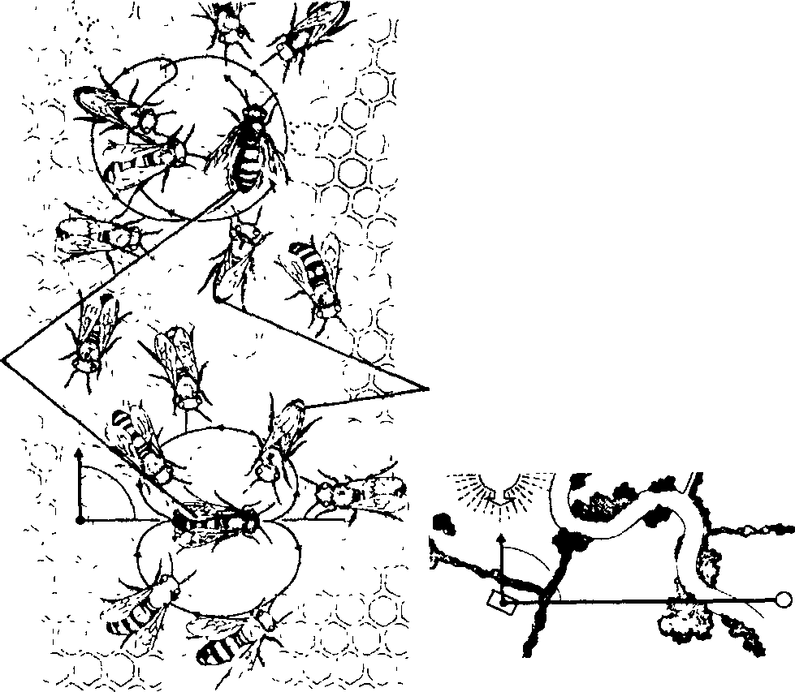

attending follower worker

sun

\

beeh ive

C

A

B

Fig. 3. The patterns of 'bee dances'. (A) Round dance, (B) Waggle dance (light coloured bees are attending follower foragers), (C) Direction of food source from hive with respect to sun.

runs with more or less frequent changes in direction. The greater dancing worker

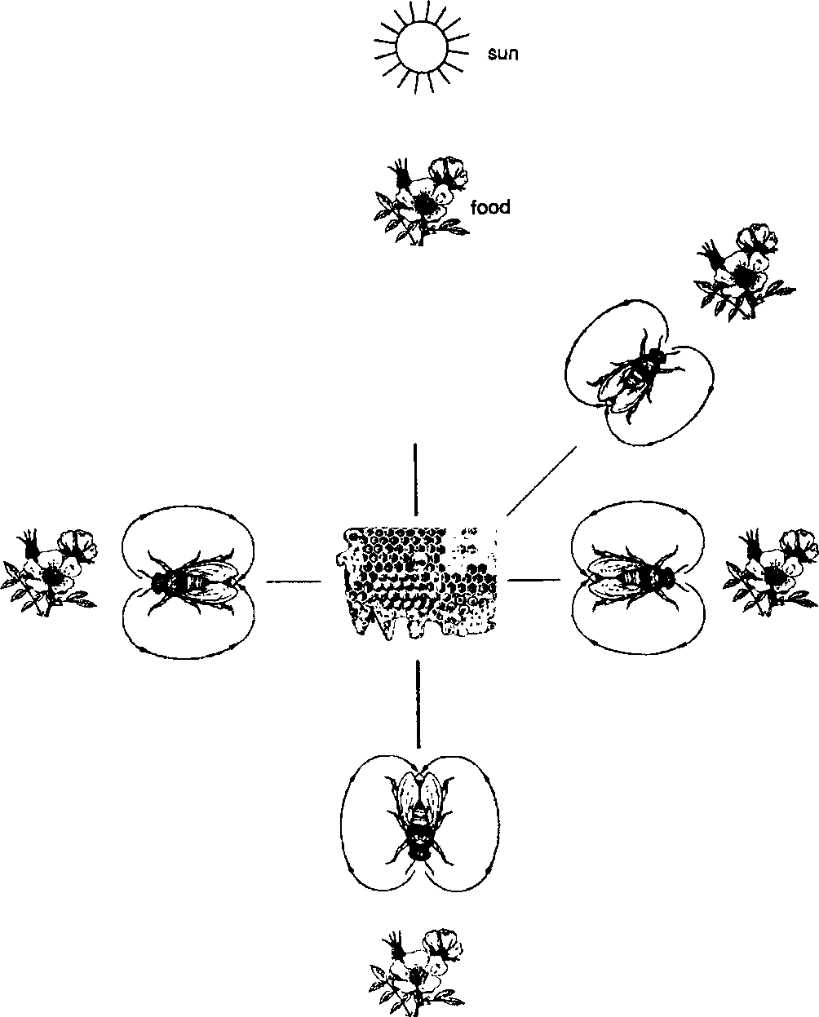source

00

food source

/·'·.

food source

beehive

food source

food source

Fig. 4. Pattern of wagging dance according to the direction of source of food from sun with respect to beehive.

frequency of direction changes indicates greater caloric value of the nectar at the food source. In this dance, there is no indication of d irection of the food source from the hive. Actually the foragers do not need such information if the food is available at shorter distance as they have very strong sense of smell which help in locating the food source. The specific scent of flowers on the body of the dancer is important. To indicate…………………………..

forager bee performs a figure intermediate between the round dance and the ''waggle dance.'' The waggle dance, used for longer distances, is a contracted figure-of-eight (fig. 3B) in which the forager bee waggles her abdomen from side to side during the straight run between the two semicircles at the ends of the figure. Distance is indicated by the duration of the straight run and the frequency of waggles which accompany it. Direction is indicated by the angle from the vertical of the straight run, which corresponds to the angle between the direction of the food source and the sun, as viewed from the hive entrance (fig. 4). Waggling, and the high-frequency buzzes which accompany it at about 250 cycles per second, may together impart information on food quality.

The bees recruited by a dance perceive all this information by touching the dancer with their antennae and by their sensitivity to air-borne vibrations (fig. 2A, B). Thus, the dance language is a ''multi-channel' ' system of communication.

Natural Eenemies and Disease of Honey Bees

The Indian bee is almost free from diseases but the European bee is susceptible to certain diseases such as foulbrood, sac brood, acarine disease etc. However, the beekeeping industry highly suffers from predators.

[ I] Natural enemies

Following are the natural enemies of honey bees :

1. Wax moths. Two moths, the greater wax moth *Galleria mellonella* and the lesser wax moth *Achroia grisella* are notorious pest of bee colony. It severely infest the week colonies where a number of comb cells are covered by the workers. The caterpillars of the wax moth live in the silken tunnels made by them and feed on the propolis, pollen and wax in the comb. The adult female moth lays 200-800 eggs in the course of 15 days usually during night in the cracks and crevices of the hive and comb. Upon hatching, the young caterpillars begin to feed.
2. Ants. The black ant *Camonotus compressus* and others are dangerous enemies of the bees. They attack week colonies and carry away the honey, pollen and the brood.
3. Wasps. The yellow banded hornet *Vespa cinca* ia a large social wasp and predates bees not only in the hives but also in fields.
4. Wax beetles. The tenebrionid beetle *Platybolium a/vearium* is observed in the hive under unhygienic conditions feeding on the debris.
5. Birds. King crow *Dicrurus* sp. and the bee eaters *Merops* spp. capture bees and feed them .

Other enemies. The death's head moth *Acherontia styx* enters the hive and feeds honey. The robber flies and leaf cutter bee *(Megachile disjuncta),* dragonflies and praying mantids capture bees and feed upon them. Even lizards, termites and mites are injurious to bee colony. *[ II]* Diseases

Honey bees suffer from several diseases caused by viruses, bacteria, fungi, protozoans and mites both in adult and larval stages.

1. Acarine disease. It is caused by an endoparasitic tracheal mite,

*Acarapsis woodi.* It is reported from Punjab, Himachal Pradesh, Uttar Pradesh and Jammu & Kashmir. In addition, several other mites also infest the honey bees such as *Varroa jacobsoni, Pyemotes herfsi, Tropilaelaps clareae,* etc.

1. Viral disease. Recently, an iridescent virus and Thai Sac Brood Virus become a major problem of bee keeping in India. Both are introduced in India through European bee.
2. Bacterial disease. The American foulbrood is a disease affecting the bee larvae is caused by *Bacillus larvae.* The Eurpean foulbrood disease is caused by *Streptococcus pluton.* Its occurrence in India is rare.
3. Protozoan disease. The Nosema disease (caused by *Nosema apis),* amoebic disease (caused by *Malpighmoeba mellificae),* septicemia (caused by *Pseudomona apiseptica)* are the example of diseases caused by parasitic protozoans. These diseases are most common in USA.
4. Fungal diseases. Honey bees are also attacked by a number of fungi causing diseases such as *A spergillus flavus, Saccharomyces* spp., *Mycoderma* spp., *Torula* spp. and *Mucor* spp. in adult bees.

Economic Importance

The economic importance of honey bees has been described earlier in this

chapter. In general the benefit of honey bees are multifaceted. The honey bees play significant role in the pollination of pigeon pea and hybrids of

sunflower increasing 27% seed setting. In cotton it increased seed yield by 1 7-1 9%. In carrot, bee pollination increased seed set by 59-7 contributing to the higher seed yield. In addition, the honey bees also

produce honey, royal jelly, propolis used as medicine as well as high

nutritious food, and beeswax used in cosmetics, making artificial beehives, candles etc. The venom of the workers is used in curing rheumatic

arthritis etc. In India, though honey production is around 11 ,00 metric tonnes/year, but technology for the production of pollen, royal jelly, bee venom and propolis on· commercial scale is yet to be developed.

Research and Training Centres in India

Among the main bee research and training centres are: the Central Bee Research and Training Institute, Pune; Khadi and Villalge Industries Commission, Pune; All India Coordinated Project on Honey Bee Research and Training, Indian Council of Agricultural Research, Hisar (the main d coordinating centre agricultural univers1ues Entomology (Apiculture),at Hisar and several cooperating centres in and institutions) and the Department of Punjab Agricultural University, Ludhiana.