**Dr. S.K.Tiwari**

**Department of Zoology, DDU Gorakhpur University, Gorakhpur**

**B.Sc. II Year, Zoology Paper II- Vertibrate Zoology**

**----------------------------------------------------------**

**Identification of Poisonous and Non-Poisonous Snakes:**

There are over 3000 species of snakes in the world out of which about 20 percent (600 species) are venomous and only 7 percent (about 200 species) of snakes are able to kill a human (WHO, 2020).

In India there are more than 350 species of snakes out of which around 69 species are poisonous comprising 29 species of sea snakes and 40 species of land snakes. In India approximately 50000 deaths occur every year by snake bites.

**A poisonous snake can be identified by careful observations of the following structures:**

**Step 1:** **Nature of the tail:**

(a) If tail is flat and laterally compressed - it is **Sea snake** and **poisonous** ( *Hydrophis, Enhydrina*)

(b) If tail is cylindrical and tapering - it is **land snake and may or may not be poisonous**.

It needs further examination.

**Step 2:** **Nature of the ventral scales:**

1. Belly scales small, uniform - it is **non-poisonous.**
2. Ventrals (belly scales) not fully broad to cover the entire belly, and there are small scales at the both ends of broad ventral scales - it is **non-poisonous** (Pythons).
3. Ventrals are broad and cover the entire width of the belly region - it **may or may not be poisonous** and needs further examination.

**Step 3:** **Nature of the head scales:**

(a) If head scales are small. Head triangular and loreal pit absent – it is **poisonous**  - Pitless Vipers.

1. Subcaudals double - it is **poisonous (***Vipera russelli).*
2. Subcaudals single - it is **poisonous** (*Echis* *carinata).*

(b) If head scales are small. A loreal pit (thermoreceptor) is present between nostril and eye, then it is **poisonous. (**Pit Vipers - *Lachesis*, *Ancistrodon*).

(c) Head with large shields and without loreal pit - it **may or may not be poisonous** and needs further examination.

**Step 4:** **Nature of the jaw scales and vertebral scales:**

1. If the vertebral scales are not enlarged, third supra labial shield (upper jaw) is large and touches the eye and nostril – it is **poisonous**
2. Neck with a hood and spectacle mark – **poisonous** (Cobra – *Naja*).
3. Hood absent and coral spots are present on belly -  **poisonous (**coral snakes – *Callophis*)*.*
4. Vertebral scales (mid dorsal on back) are enlarged, hexagonal and fourth infra-labial scales are largest - it is **poisonous (**Krait – *Bungarus*).
5. No such characters – **Non-poisonous**.

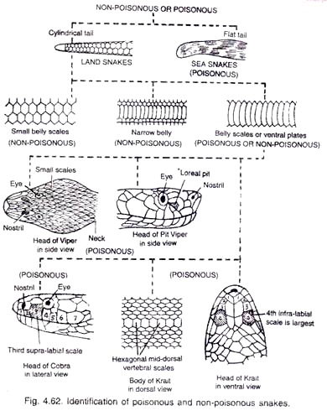

Fig. Identification of Poisonous and Non-poisonous Snakes

**Poisonous snakes in India:**

In India around 60 venomous species are present, out of which four are the deadliest refereed as Big four:

1. Russell’s viper (Daboia russelii)

2. Common krait (Bungarus caeruleus)

3. Indian Cobra (Naja naja)

4. Saw-scaled viper (Echis carinatus)