**Dr.S.K.Tiwari,**

**Deptt. of Zoology, DDU Gorakhpur University, Gorakhpur**

**M.Sc.IV Semester Zoology(Entomology): Paper Ist (4101)-Insect Morphology, Physiology and Development**

---------------------------------------------------------------------------------------------

**Digestive System of Insect**

Digestive system is composed of alimentary canal (digestive tract) and various glands related with it either directly (salivary glands, gastric caeca), or indirectly (Malpighian tubules).

Description of anatomy, histology etc. of a generalised insect is based on the orthopteroid plan (e.g., grasshoppers, crickets, and locusts) as it exemplify the basic, primitive design from which other insect groups evolved modifications and specialisations. One of the major reasons for the biological success of insects is their ability to eat, digest, and utilise an enormous diversity of foods. This ability allows the extreme diversity observed in the modifications and specialisations of the alimentary system of insects. The structural and biochemical modifications of the alimentary system of a particular species depend upon the type of food eaten. There are structural and functional differences in the way foods are obtained, stored, processed, and absorbed between the different life stages and between the sexes, e.g., caterpillars chew up plant material, whereas adults suck up only floral nectar and female mosquitoes suck up a vertebrate blood, whereas males suck up plant sap.

**Alimentary Canal**

The alimentary canal of the insects is a tube, which extends from the anterior oral opening, the mouth, to the posterior anus. The gut is formed by a one-cell-thick layer of epithelial cells lying on a non-cellular basement membrane (basal lamina). Ingestion, trituration (chewing), digestion, absorption into the haemolymph, and egestion are associated with it.

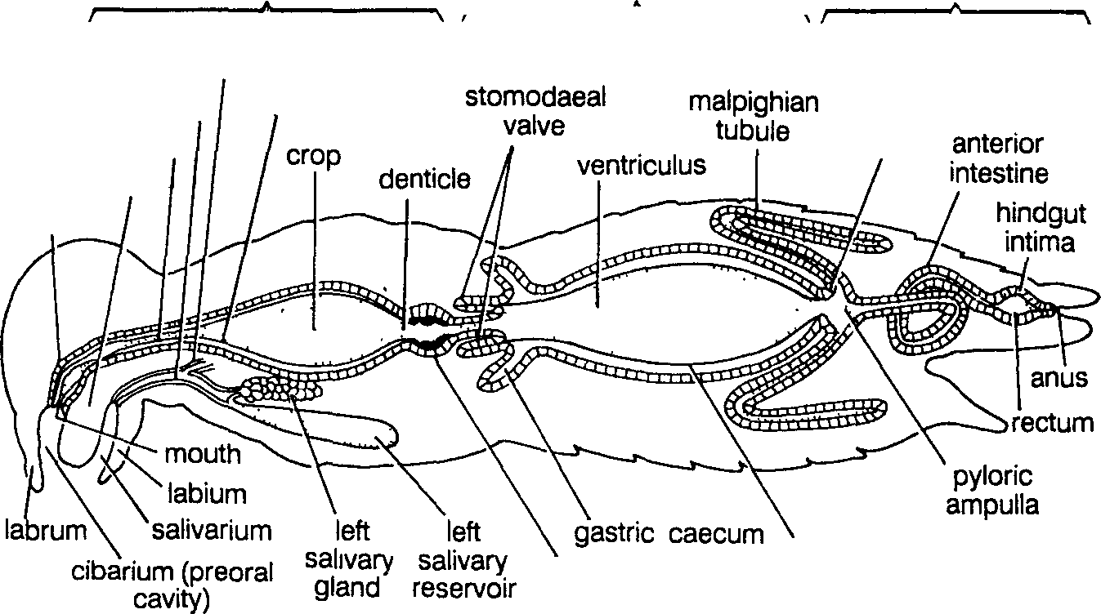

foregut

to right salivary gland and reservoir

midgut

hindgut

pyloric

oesophagus valve

hypopharynx pharynx

proventriculus

peritrophic membrane

foregut intima

salivary duct

Fig. 1. Alimentary canal of a generalised msect

Alimentary canal (Fig. 1) is divided into three distinct regions, the anterior foregut (stomodaeum), the midgut (mesenteron) and the posterior hindgut (proctodaeum). The foregut and hindgut arise as invaginations of the ectoderm, are lined with a chitinous intima, which is continuous with the cuticle of the integument and therefore, at the moult, both foregut and hindgut and their contents are shed. The midgut is derived from endoderm. Longitudinal and circular (intrinsic) muscles are associated with the alimentary canal. The anterior alimentary canal muscles are innervated by the stomatogastric system, and the posterior muscles are innervated by nerves from the posterior ganglion of the ventral chain. In addition to muscles, tracheae and tracheoles provide support for the gut. The alimentary canal tends to be shorter in species that exist on high-protein diets (carnivorous) and longer in those with high-carbohydrate diets (phytophagous).

**[ I] Foregut or stomodeum**

Foregut with its various morphological divisions serves mainly as a conducting tube, carrying food from the pre�oral cavity to Hie midgut. The mouth lies at the base of hypopharynx within the preoral cavity (cibarium) formed by the mouthparts. It communicates directly with the pharynx that varies greatly among different insects. In sucking insects (e.g., mosquitoes, bugs) the cibarium and pharynx both form suctorial pump with well-developed dialator muscles. The pharynx leads to the oesophagus, which is commonly enlarged posteriorly to form the crop to store the food

(Fig. 1 ). Immediately posterior to the crop is the proventriculus or gizzard

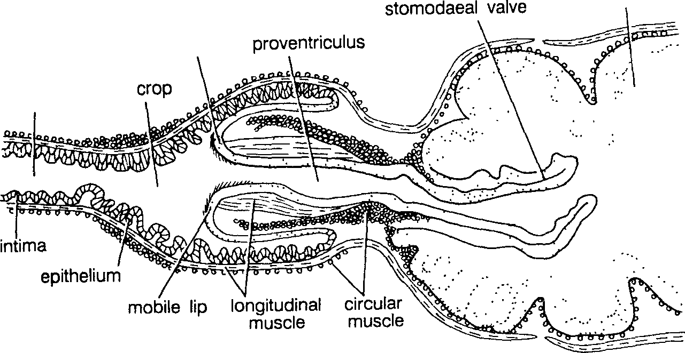

midgut

mouth of proventriculus

oesophagus

Fig. 2. Longitudinal section of the proventriculus of honey bee

which is variously modified in different insects. It is absent in fluid feeder but is well developed in orthopteroid insects (e.g., cockroach). In cockroach and crickets, the intima in the proventriculus is developed into six strong teeth for grinding the food. Spines in the proventricular region may act together as a food sieve or filter. The proventriculus typically communicates with the midgut by stomodaeal valve. In honey bees, for example, proventricular spines allow the movement of pollen into the midgut without admitting ingested flower nectar. The stomodaeal valve is developed to varying degrees in different insects (Fig. 2) .

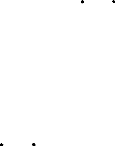Although the foregut is not the major digestive region of the alimentary canal, some digestion may occur in the crop by the action of salivary enzymes and enzymes regurgitated from the midgut (e.g., in the cockroaches). Due to presence of impermeable mtima, the foregut probably plays no major role in the absorption of digested food.

**[ II] Midgut or mesenteron or ventriculus**

The midgut (Fig. I) does not have a cuticular mt1ma but, in the ma1onty of insects, it is lined by a delicate peritrophic membrane which is composed of chitin fibrils in a protein-carbohydrate matrix (Fig. 3). Immediately posterior to the stomodaeal valve there is commonly a group of diverticula, the gastric caeca. The number of these caeca varies in different species. In bugs, the midgut is divided into two, three, and four distinct regions.

The midgut epithelium of most insects is composed of three basic cell types: columnar digestive cells with microvilli forming a striated border regenerative cells and endocrine cells. The basal plasma

Fig. 3. (A) Transverse section of midgut. (B) A section of midgut more highly magnified.

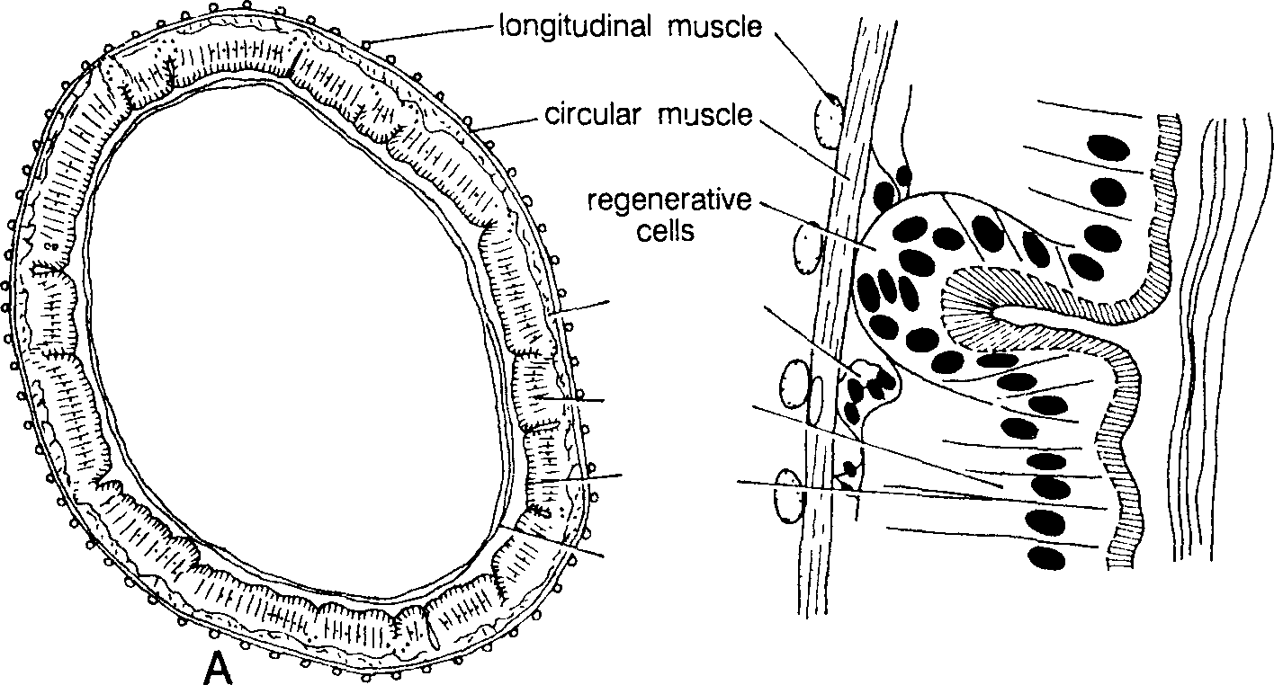

cotnisnseucetive

seceelltsory /

sbtoriradterd pmeenmtrborpahnice

B

membrane of digestive cells is characteristically infolded, and mitochondria are associated with these folds. These cells are involved in the synthesis of digestive enzymes and absorption of digested food. At the bases of the midgut epithelial cells are small regenerative cells, or replacement cells. These cells replace the actively functioning gut cells that die or that degenerate as a result of holocrine secretion.

The peritrophic membrane (peri=around; trophic=food) surrounds the food bolus and may protect the epithelial cells from possible abrasion by food particles. It is permeable to enzymes and the products of digested food. The bugs, which are fluid-feeders, lack a peritrophic membrane.

The plant bugs in order to obtain adequate quantity of nutrients ingest large amount of sap. In them, the gut is modified to provide the rapid elimination of the excess of water taken in to avoid excessive dilution of the haemolymph and to concentrate the food to facilitate enzyme activity. In leaf hoppers and aphids, the rapid removal of water to the rectum is achieved by the anterior midgut forming a large thin-walled bladder which is closely bound to anterior hindgut and Malpighian tubules by its own basement membrane. The chamber formed within this fold is called the filter chamber (Fig. 4). Water passes directly from the midgut to the hindgut along an osmotic gradient and there may be no significant flow of fluid through the lumen of the gut.

**[ III] Hindgut or proctodeum:**

The hindgut (Fig. 1) is composed of cuboidal epithelial ceHs and is lined by a layer of cuticle which is thinner and more permeable than that of the foregut. It commences with the pylorus, which is associated with a variable number of typically slender, elongate excretory structures, the Malpighian tubules, and which usually contains a valvular structure, the pyloric valve. The hindgut is divisible into an undifferentiated tubular anterior intestine, just posterior to the Malpighian tubules, and a highly muscularised, enlarged rectum, which terminates with the anus.The anterior intestine may be differentiated into an anterior ileum and posterior colon. The rectum usually contains a number of pads, or papillae (usually six), that project into the lumen. These structures receive an extensive supply of tracheae and are metabolically very active. They play an especially important role in the excretory system. The hindgut is the major region of the insect involved in recycling. Here needed materials are "reclaimed" while excess or waste materials are ' 'trashed.'' Functions of the hindgut include the following: (i) water absorption from urine and faeces, (ii) ion absorption from urine and faeces, (iii) cryptonephridial system for water conservation, (iv) pheromone production, (v) respiration in larval dragonflies, and (vi) modifications in structure for housing symbiotic microorganisms (e.g., termites).

Fig. 4. Filter chambers of bugs. (A) Filter chamber with straight ventriculus, (B) Filter chamber with convoluted ventriculus, (C) T.S. filter chamber.

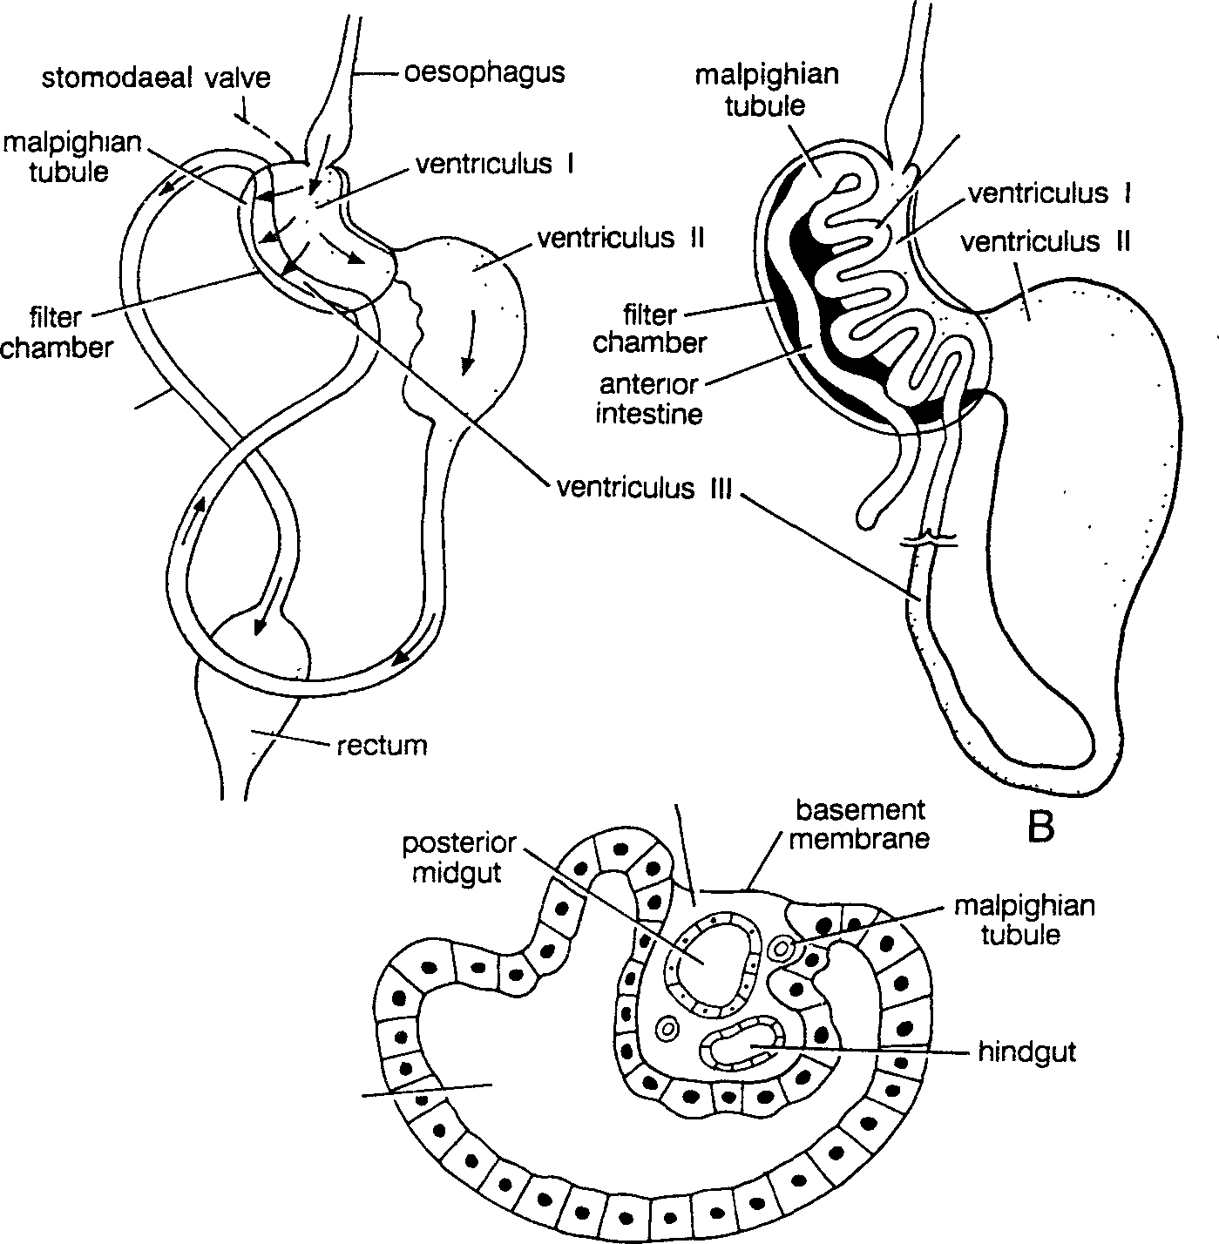

vecnotnrivcoululutsedIll

inasntteesrtioinre

chfailmtebr er

A

anterior midgut

**Salivary Glands:**

Although there may be glands associated with the mandibles (e.g., silver fishes, termites, queen honey bee), maxillae (e.g., proturans, spring-tails), and hypopharynx (e.g., worker honey bees), salivary glands are typically associated with the labial segment. The salivary glands or labial glands (Fig. 5) are paired structure, lie ventral to the foregut in the head and thorax and occasionally extend posteriorly into the abdomen. Depending on the type of food eaten and the insect species involved, salivary glands vary in size, shape, and the type of secretion produced. Two basic types of salivary glands exist, acinar and tubular. Orthoptera and Dictyoptera have the acinar type while Diptera, Lepidoptera, and Hymenoptera have the tubular type. In the acinar type, each acinus, bears a tiny duct that communicates with other similar ducts, eventually forming a lateral salivary duct. Lateral salivary ducts run anteriorly and merge as the common salivary duct, which empties between the base of the hypopharynx and the base of the labium. This region is called the salivarium and in some sucking insects forms a salivary syringe that "injects" saliva into whatever is being pierced. The lateral salivary ducts may communicate with salivary reservoirs, as in the cockroaches. The secretory products of the salivary glands are generally clear fluids that serve a variety of functions in different insects: (i) they moisten the mouthparts and serve as a lubricant, (ii) they act as a food solvent, (iii) they serve as a medium for digestive enzymes and various anticoagulins and agglutinins, (iv) they secrete silk in larval Lepidoptera (caterpillars) and Hymenoptera (bees, wasps, and relatives), they are used to "glue" puparial cases to the substrate in certain flies,they serve for the production of toxins, and (vii) theysecrete antimicrobial factors (e.g., in certain blow fly larvae).

Amylase and invertase are the most common enzymes found in saliva of insects, however, the saliva may also contain lipase and protease.Aphids secrete a pectinase that aids their mouthparts in the penetration of plant tissues. The spreading factor, hyaluronidase, which attacks a constituent of the intercellular matrix of many animals, has been found in the assassin bug.

Blood-sucking (haematophagous) insects contain various antihaemostatic (anticoagulant) agents. Current evidence, al least for mosquitoes, is that these various salivary components mainly increase the chances of the female locating a blood vessel. Production and secretion of saliva in the dragonflies, grasshoppers, and cockroaches are regulated by nervous innervation from both the stomatogastric nervous system and the subesophageal ganglion, whereas in the Diptera (e.g., the adult blow fly) these glands are controlled by an unidentified neurohormone. Salivation has been shown to be controlled by phagostimulation of external chemoreceptors on the mouthparts. This same stimulus probably also activates the salivary pump.

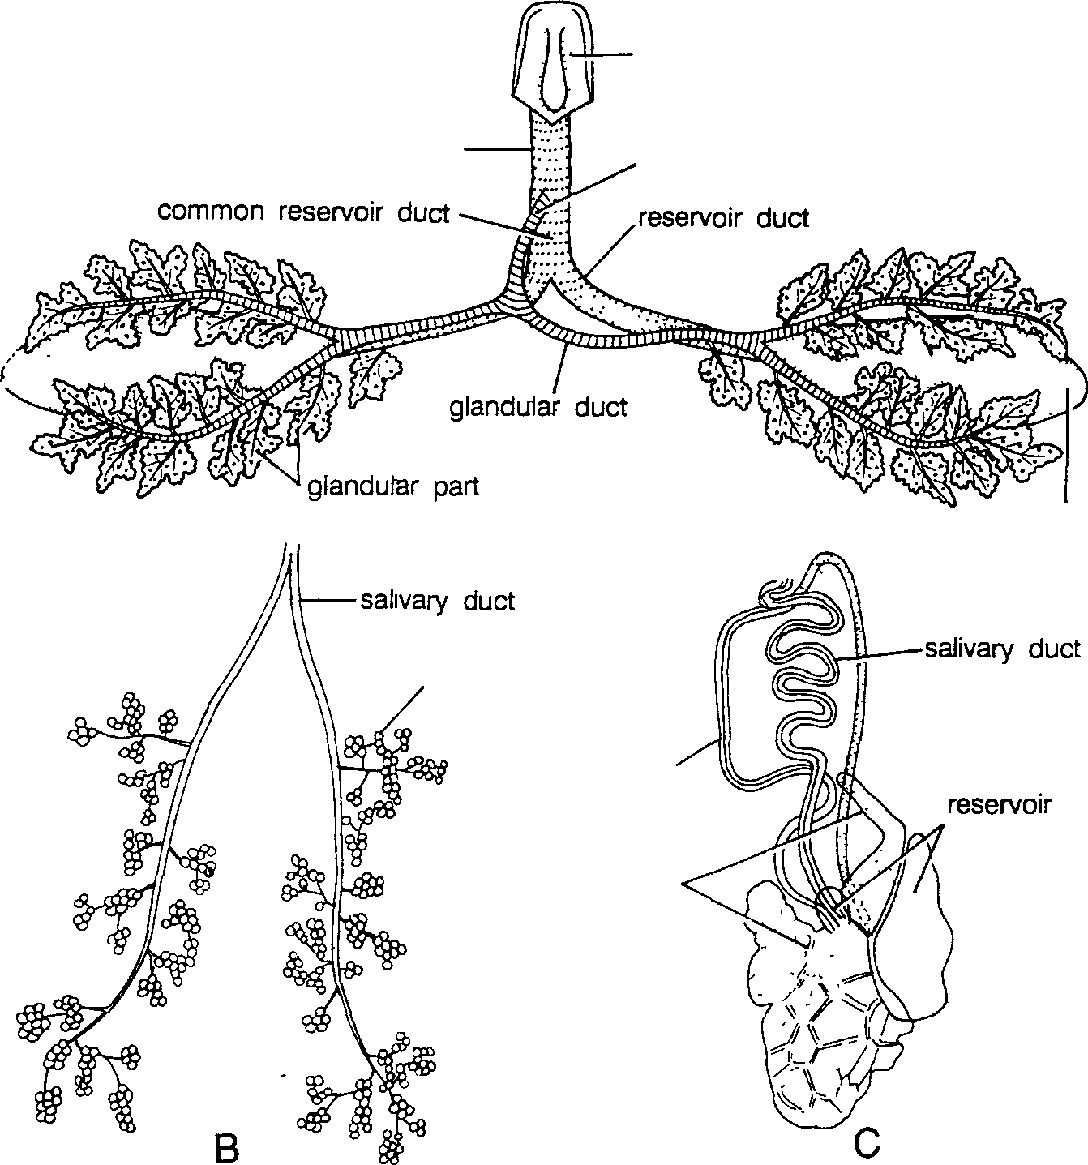

hypopharynx

common efferent duct

common glandular duct

A

reservoir

glandular part

reservoir duct

glandular part

Fig. 5. (A) Salivary glands of cockroach, (B) grasshopper and (C) red cotton bug.

**Physiology of Digestion:**

In fluid feeders, digestion may begin before the food is ingested through the injection or regurgitation of enzymes on to the food, or in foregut but in general most digestion occurs in the midgut where most of the enzymes are produced. In insects having biting and chewing type of mouthparts, food is masticated not only in the buccal cavity but also in the proventriculus. This not only facilitates passage through the alimentary canal but increases the surface area for enzymatic action. Digestion takes place by a series of progressive enzymatically catalysed steps, each producing a simpler substance until molecules of absorbable size or nature are produced. For example, polysaccharides are broken down into small chains, disaccharides, and finally into simple, absorbable monosaccharides (e.g., glucose); proteins are broken down into peptones, small polypeptides, dipeptides, and finally into amino acids, which are absorbable.

There is some correlation between the kinds of food material eaten by and the kinds of enzymes present in a given insect. Thus, cockroach which is omnivorous secretes more enzymes than tsetse fly, that feeds primarily on blood. In addition, different enzymes may be secreted by different parts of the midgut epithelium.

[ I] **Extra-intestinal digestion:**

Digestion of the food taking place outside the alimentary canal before the food is ingested is known as extra-intestinal digestion. It happens with fluid feeders where salivary enzymes are injected onto the food (e.g., house fly), or into the host in predatory or parasitic insects, for example, assassin bugs inject saliva into the prey which histolyses the contents before ingestion.

**[ II] Intestinal digestion:**

In general, most of the digestion occurs in the midgut where enzymes are secreted, however, some digestion also takes place in foregut, particularly in crop, where midgut enzymes are regurgitated into it. In locust, the major proportion of digestion takes place in crop.

The enzymes synthesised in the midgut depend upon the diet as given in the table. For example, insects feeding protein diet proteases are important, whereas a nectar feeding butterflies they are absent. Aphids feeding on phloem sap having no polysaccharides or proteins lack amylase and proteinase but have invertase (Table 1).

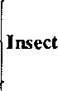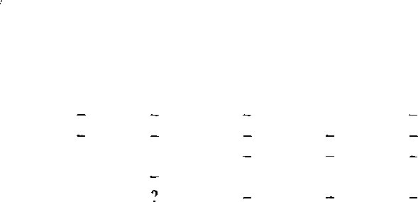Table 1. The midgut enzymes secreted by insects with different diets (+ and - indicate presence and absence of enzymes).

|  |  |  |  |  |  |  |
| --- | --- | --- | --- | --- | --- | --- |
| Diet | | Protease | Lipase | Amylase | Invertase | Maltase |
| Cockroach | Omnivorous | + | + | + | + | + |
| Stick insect | Phytophagous | + | + | + | + | + |
| Moth and butterfly |  |  |  |  |  |  |
| Larvae | Phytophagous | + | + | + | + | + |
| Adults | Nectar |  |  |  | + |  |
| Adults | non-feeding |  |  |  |  |  |
| Flesh fly larvae | Meat | + | + |  |  |  |
| Flesh fly adults | Sugar | weak |  | + | + | + |
| Tse tse fly | Blood | + |  |  |  |  |

1. **Digestion of carbohydrates.** Carbohydrates are generally absorbed as monosaccharides so that, before they are absorbed, disaccharides and polysaccharides must be hydrolysed to their component monosaccharides.
2. *Polysaccharides.* Starch, glycogen, chitin and cellulose are the maj or polysaccharide food to be digested by different insects. Starch (amylose) is hydrolysed to maltose, and glycogen to glucose by the action of amylase, which specifically catalyses the hydrolysis of 1 :4-a-glucosidic linkage in polysaccharides. The major portion of the food of phytophagous and xylophagous insects contains cellulose, only few insects *(Ctenolepisma, Schistocerca* and some psocids) are able to secrete cellulase. The insects unable to secrete cellulase, either cellulose is excreted as such or they harbour micro-organisms (bacteria, flagellates) to secrete cellulase.

Other polysaccharides, viz., chitin, lignocellulose and hemicellulose are digested by chitinase, lignocellulase and hemicellulase, respectively.

1. *Disaccharides.* The common disaccharides in the food are maltose, trehalose, sucrose, cellobiose, melibiose and lactose that contain a glucose residue which is linked to a second sugar residue by either α-linkage or β-linkage. In the hydrolysis water molecule is the typical acceptor for the sugar residues as follows :

Maltose+H20 → Glucose + Glucose [enzyme : maltase]

Trehalose+H20 → Glucose + Glucose [enzyme : trehalase]

Sucrose+H20→Glucose + fructose [enzyme : sucrase] Cellobiose+H20 → Glucose + Glucose [enzyme : cellobiase] Melibiose+H20 → Galactose + Glucose [enzyme : melibiase]

Lactose+H20 → Galactose + Glucose [enzyme : lactase]

1. **Digestion of proteins.** Insects possess a series of proteases. A trypsin like proteinase is secreted in the midgut which hydrolyses protein to peptones and polypeptides. The products are then broken down by peptidases. The carboxypolypeptidase attacks peptide chain·from the-COOH end and aminopolypeptidase attacks the chain from the -NH 2 end). Some of these occur in the gut lumen, but most of them are found in the intestinal epithelium. It indicates that most of the polypeptides are absorbed before being further digested to amino acids. Certain insects are able to digest ordinarily stable proteins. For example, chewing lice and a few other insects are able to break down keratin, a protein that occurs in hair and feathers.
2. **Digestion of lipids.** Many insects secrete lipases which hydrolyse fats to fatty acids and glycerol. Wax moth *(Galleria)* is able to digest beeswax (a mixture of esters, fatty acids and hydrocarbons). The insect is known to produce not only the lipase, but also lecithinase and cholinesterase with the help of bacteria.

Midgut pH (typically pH 6-8), buffering capacity, oxidation-reduction potential, and temperature are important factors in the digestive process. These factors vary from species to species and may also vary from one region of the midgut to another within the same insect.

**[ Ill] Absorption of the digested food:**

The midgut is the major site of absorption. In hindgut only reabsorption of urine components occur while in foregut no absorption takes place. All the substances are absorbed in solution and no phagocytosis of food particles occurs. There are three major factors that affect the absorption of digested food materials: (i) the presence of microvilli, which increase the surface area for absorption; (ii) the functional differences in membrane permeability of various regions of the digestive tract; and (iii) the presence of a counter-current. Absorption may be active or passive. Passive absorption (diffusion) takes place from the higher concentration inside the lumen of the gut to lower one (inside the gut epithelium). Active absorption depends on some metabolic process for movement of a substance against a concentration or electrical gradient.

1. **Carbohydrates.** Carbohydrates are mainly absorbed as monosa­ ccharides that diffuse down concentration gradients between the midgut lumen and haemolymph. The diffusion of simple sugars like glucose and fructose is enhanced by the rapid conversion of these sugars to trehalose in the fat body, a process called facilitated diffusion that maintains a concentration gradient across the gut epithelium. Some insects are able to absorb disaccharides as such.
2. **Proteins.** Protein& are absorbed as amino acids after hydrolysis mainly in the midgut and caeca. Some amino acids in urine are also reabsorbed in hindgut. Insects are unique in that they maintain rather high levels of free amino acid stores in the haemolymph, thus many amino acids have to be actively absorbed against a concentration gradient. Some insects are able to absorb peptide fragments or even the protein as such, e.g., midgut cells of a haematophagous bug *Rhodnius* absorb haemoglobin as such. Active absorption of amino acids varies among insect species and depends on the composition of the diet and the haemolymph.
3. **Lipids.** Like some disaccharides and proteins, lipids are also sometimes absorbed unchanged. The products of wax are absorbed in a phosphorylated form while cholesterol is esterised before absorption. The midgut caeca appear to be particularly active in lipid absorption, but in few insects like adult Hymenoptera, lipid is absorbed in hindgut.
4. **Water.** Water is absorbed mainly in midgut and also in hindgut either by diffusion or active transport depending upon the need of the insect as insects regulate the salt-water balance very precisely. As the amount of food is very poor in the contents of phloem and xylem, insects feeding on them, e.g., plant bugs, in order to obtain sufficient amount of amino acids and other nutrients, they possess various mechanisms for concentrating the necessary nutrients from a dilute food source by eliminating water. The filter chamber, present in the Cicadoidea and Cercopidae (order Homoptera), is a modification of the anterior midgut, which in combination with the Malpighian tubules facilitates water removal and concentration of the desired nutrients prior to absorption.
5. **Inorganic ions.** Inorganic ions are absorbed in the midgut and reabsorbed in the fluid in the rectum. Even in the midgut, there are specified cells that absorb particular ions, e.g., F + and cu++ All the three ions Na+ , K+ and c1 - are absorbed actively as their concentration is very high in haemolymph than the gut lumen.

/

The active transport of Na+ may play a key role in the diffusion of other molecules. When Na+ molecules are pumped from the midgut cells into the haemocoel, they are replaced by Na+ diffusing into the midgut cells from the lumen. The movement of Na+ across the cells tends to produce a water gradient between the lumen and the cells concentrating water in the lumen. Hence, water would diffuse into the cells which, in tum, tend to concentrate other molecules that would then diffuse down gradients into the cells. It implies that the work necessary to produce the gradients for diffusion (a passive process) of water and other absorbable molecules would be the active transport of Na.+

[ IV] **Regulation of the alimentary system:**

Regulation of the alimentary system in insects involves control of food movement, control of enzyme secretion, and control of absorption. The alimentary canal is regulated in part through the action of the stomatogastric nervous system. Food is ingested by the actions of the mouthparts, cibarium, and pharynx, and is typically stored in the crop. It is then released gradually, via the stomodaeal valve, into the midgut, where digestion and absorption occur. In most insects that have been studied, stretch receptors associated with the crop provide information to the brain (via the frontal ganglion) regarding crop distension and help prevent overfilling of this organ. In some insects, stretch receptors in the abdominal wall have a similar role.

The destination of ingested food may vary with the kind of food. For exaThple, in female mosquitoes sugar meals (flower nectar) are directed to the diverticula and blood meals are directed to the midgut. Sensilla in the roof of the cibarial pump, acting via the frontal ganglion, are thought to be involved in this so-called "switch mechanism." In other blood-feeding insects, such as tsetse flies, ingested blood goes to the crop first.

Control of passage of food from the crop to the midgut (rate of crop emptying) has been studied mainly in the cockroach, *Periplaneta americana.* Passage of food from the cockroach crop is inversely related to the osmotic pressure of the food, i.e.. the higher the concentration of food, slower the passage. Osmotic receptors have been identified in the wall of the cockroach pharynx.

Two mechanisms for the control of enzyme secretion in the insect gut have been suggested : Secretogogue (a substance in the ingested material may stimulate enzyme secretion) and hormonal. The secretogogue control is an immediate response to food, whereas hormonal control is more related to developmental and environmental effects. Nervous control is highly unlikely because the midgut is sparsely innervated or not at all.

Absorption appears to be controlled by the availability of absorbable Tholecules, release of food material from the crop being so regulated that digestion and subsequent absorption occur at an optimal rate for a given circumstance.

Many insects ingest foods with a very high water content. Some of these insects (e.g., butterflies and many true flies) store the dilute food in the imperTheable crop and pass it gradually to the midgut. In others (e.g., many blood-feeding insects) food may go to the midgut where excess water is rapidly absorbed in the haemolymph and then excreted via the Malpighian tubules. Both mechanisms probably prevent extensive dilution of the haemolymph, and removal of water concentrates solid food, increasing the efficiency of digestion.

Movements of the alimentary canal (mainly foregut and hindgut) that complement the actions of the digestive enzymes and help absorption are under neural or neurosecretory control in some insects. In others, having no neural connections, gut movements are assumed to be myogenic. Hormonal stimuli may also have a great deal to do with the rate of gut movements.

[ IV]  **Insect nutrition** Like other animals, insects also require a balance diet having appropriate amount of proteins, amino acids, carbohydrates, lipids, vitamins, minerals etc. The dietary requirement of the insect is species specific. For the proper development and growth, the insects derived most of the nutrients either by taking food, or from the stores inside the body (e.g., fat bodies), or as a result of synthesis (by the insect itself or through associated micro-organisms). Certain moths do not feed as adult, and the food accumulated during larval stages is used for their metabolic processes. All insects are able to synthesise nucleic acids, however, only some insects are able to synthesise vitamins, non-essential amino acids .

* + - 1. **Amino acids.** Amino acids are the building blocks of protein making the tissues and enzymes. Different insects have different requirements, depending upon which amino acids they are capable of synthesising. In addition to essential amino acids, few insects need glycine (e.g., flies) or alanine (e.g., *Blatella),* however, in these cases methionine is not essential.
      2. **Carbohydrates.** Carbohydrates are not considered to be essential nutritive substances for most insects, but they are probably the most comon source of chemical energy utilised by insects. However, many insects (e.g., many moths) do, in fact, need them if growth and development are to occur normally. The carbohydrates may be converted to fats for storage, or to amino acids.
      3. **Lipids.** Lipids or fats, like carbohydrates, are good sources of chemical energy and are also important in the formation of membranes and synthesis of steroid hormones. Most insects are able to synthesise lipids from carbohydrate and protein sources. However, some insect species do require certain fatty acids and other lipids in their diets. For example, certain Lepidoptera require linoleic acid for normal larval development. All insects need a dietary source of sterol (cholesterol, phytosterols, or ergosterol) for growth and development. Carotenoids are necessary in the diets of all insetcs as the visual pigThent retinene is derived froTh the food.
      4. **Vitamins.** VitaThins are unrelated organic substances that are needed in very small amounts in the diet for the normal functioning of insects as they cannot be synthesised. They provide structural components of coenzymes. Vitamin A (fat soluble) is required for the normal functioning of the compound eye of the mosquito. Insects principally require water-soluble vitamins (e.g., B complex vitamins and ascorbic acid). In the absence of ascorbic acid (vitamin C) locusts undergo abortive moults and dies.
      5. **Minerals.** Like vitamins several minerals are required in traces by insects for normal growth and development, e.g., potassium, phosphorus, magnesium, sodium, calcium, manganese, copper, iron, chlorine, iodine, cobalt, nickel and zinc. The aquatic larvae of mosquitoes are able to absorb mineral ions from the water through the thin cuticle.
      6. **The nucleic acids.** Nucleic acids (DNA and RNA) constitute the genetic material. Like other animals, insects are also able to synthesise them. However, dietary nucleic acids (e.g., RNA) have been shown to have an influence on growth of certain fly larvae.
      7. **Water.** Like all animals, insects require water. Insects fulfil their water reqmrements from food, by drinking, from absorption through the cuticle (in aquatic forms), or from a by-product of metabolism. Insects vary greatly with respect to amounts of water needed. Some, like the rice weevil *(Sitophilus oryzae),* can survive and reproduce on essentially dry food. Others, for example, honey bees and house flies, require large amounts of water for survival. The excrement of the rice weevil is hard and dry, with almost all the water absorbed by the insect, while the excrement of bees and house flies contains large amounts of water.

**[ VI] Microbiota and nutrition**

Some insects require the presence of certain microbes (yeasts, fungi, bacteria, and protozoans) for normal growth and development and, in some instances, for survival. In some insects the microbes are housed in specialised cells, mycetocytes, and the tissues composed of these cells, mycetomes, are associated with the gut, fat body, or, appropriately, the gonads. The presence of microbes in the gonads ensures the infection of any egg produced, thus transferring the microbes in next generation. Microbes are commonly found in the alimentary canals of insects, often in the various diverticula of the midgut. The microbes probably benefit the insect in various ways, e.g., fix atmospheric nitrogen, synthesise protein from nitrogenous waste materials, and supply vitamins (B group), sterols, and amino acids in addition to digestion of cellulose.

The association of microbes with the insects may either be casual or constant. The microbes are almost present in food and are ingested by the insects during feeding, e.g., locusts. Such casual association with microbes are important in the nutrition of dung beetles that have fermentation chamber in the hindgut in which decaying food with its content of microbes is retained. The insects may have constant association with the microbes, e.g., insects feeding on wood, dry cereal, feather, and hair.

**Feeding Behaviour**

[ I] **Types of feeding**

The food of the insect is intimately associated with the habitat where it is found. On the basis of food (biological source of nutrients), insects may be classified as herbivores (phytophagous: plant-eating), carnivores (zoophagous : animal-eating), omnivores (eating a wide variety of food), detritivores (saprophagous : debris-eating), microphagous (feeding on micro-organisms) and mycetophagous (fungus-eating).

**1.Herbivores.** Plants are the main source of food for the largest number of insects, and the insects developed a variety of way to take them. Grasshoppers, locusts, bugs, moths, butterflies, thrips, termites, fruit flies, several beetles, wasps, bees are herbivorous. On the basis of kind of food the herbivores may be either monophagous feeding on plants belonging to a particular species or genus, (e.g., mustard sawfly, cabbage butterfly), polyphagous feeding on a variety of plants distantly related taxonomically (e.g., desert locust), or oligophagous feeding on plants of same family or superfamily (e.g., pumpkin beetles). Insects are able to feed roots, stems, woody parts, buds, flowers, and fruits. However, a given insect is usually rather specific for the part of the plants it eats. Thus there are leaf rollers, leaf miners, rootworms, root borers, stem borers, fruit borers, and so on.

1. **Detritivores.** Detritivorous insects feed on decaying organic materials, e.g., leaf litter, decaying flesh, dung, and so on. Such materials are supposed to be basic food source for the most primitive insects living on the forest floor. These insects are important in the progressive degradation of decaying organic material. For examples, dung beetles, carrion beetles, and many of the soil-inhabiting apterygotes (e.g., Collembola).

3. **Microphagous.** Several insects are dependent upon micro-organisms closely associated with decaying organic material, e.g., the fruit fly, *Drosophila melanogaster.* Its maggots cannot live on a sterileculture medium.

1. **Mycetophagous.**  Many insects feed upon fungi and to obtain it they grow fungi on specially prepared substrates. Such a relation is mutual. The fungi and the insects both derive benefit, e.g., few species of ants *(Acromyrmex, Atta)* and termites *(Macrotermes, Odontotermes).* The fungus is eaten in small amount by the workers and is fed to some of the larvae.
2. **Carnivores.** Insects that use living ·animals as a source of food are called carnivores. They are either predators, parasites or parasitoids (insect parasiting insects).
3. ***Predators.***Predatory insects capture and eat Thany living animals (prey, usually other insects), e.g., praying mantids, dragonflies, robber flies, ladybird beetles, tiger beetles, sphecids, predatory wasps, antlions, lacewings etc. Predatory insects usually possess speed and agility. Adult robber flies and dragonflies capture their prey in mid-air. The praying mantid relies on stealth, extremely accurate visual targeting and a lightening strike to trap its prey by the raptorial forelegs. Certain insects, such as antlion larvae literally trap their prey forThing a shallow cone-shaped pit ·in a sandy area and bury itself just beneath the surface at the bottom of the pit. The aquatic larvae of certain species of caddisflies construct silken nets in which they are able to catch small organisms. The eggs of aphidophagous insects are placed in proximity to prey species, e.g., hover flies. Giant water bugs *(Belostoma)* feed upon snails.
4. ***Parasites.***The parasites live on or within the hosts which are other than insects, particularly vertebrates and do not kill the host but may spread diseases into them. Ectoparasitic insects obtain all or part of their food from the host and live entirely on its external surfaces, e.g., *Pediculus* (human lice), *Xenopsylla* (rat flea), *Cimex* (bedbug) etc. Some of these insects remain on the host throughout their life-cycle, some live on the host only during a particular stage of the life cycle, and others visit the host intermittently during a particular stage of the life cycle and are otherwise free-living. Parasitic insects that remain on the host (e.g., the lice) are host specific. Adult fleas live on the host while their larvae are free-living and detritivorous. In case of mosquitoes adult females visit host only to take a blood meal and of the host, e.g., *Gasterophilus* (live inside the gut of cattle). exhibit varying degrees of host specificity. Endoparasitic insects live inside host and feed the tissues
5. ***Parasitoids.***The parasitoids are those insects whose larvae live and feed within (endoparasitoid) or on the host (ectoparasitoid) and adults are free-living. The Thajority of parasitoids belongs to the order Hymenoptera. Some parasitoids exhibit a high degree of host specificity, attacking a single or very few species of insects. A single host may support the development of only one parasitoid (solitary parasitoid, e.g., aphid parasitoids) or several parasitoids (gregarious parasitoids, e.g., *Apanteles* - a braconid wasp). The parasitoids do not kill the host immediately, but the hosts are ultimately killed after the development of the larvae to pupae. Some parasitoids attack other parasitoids (hyperparasitoids), e.g., a cynipoid wasp *Alloxysta pleura/is* parasitises a braconid wasp *Binodoxys indicus* which in turn parasitises plant lice. Several parasitoids have been used in biological control of insects pests.
6. **lnquilines.** The inquiline insects live and feed as permanent residents in the shelters of other insects (both social and non-social). For example, certain galls made by one species are shared by larvae of another species without any apparent damage to the original owner, e.g.. ants of different species share common colony.
7. **Trophallaxis.** The trophallaxis is the phenomenon of mutual exchange of food between adults and their larvae , e.g., an ant when feeds a larva, it receives from the larva a drop of fluid (secreted by salivary glands or integument or exudatoria) which is highly acceptable to their nurses. This mutual exchange of food is the basis of social system in insects. Trophallaxis also occurs in certain wasps *( Vespula)* but in them its function is the disposal of excess water produced by larvae . The rectal symbionts in termites are passed from one generation to the next by means of anal trophallaxis.

**[ II] Location of food sources**

In Thany herbivorous insects, the feThale parent oviposits on or in the vicinity of a food source for her offspring. The saThe is true for Thost parasitic insects. In these cases location of oviposition site, host location, and food location are not distinctly separate activities.

Visual and olfactory stimuli are probably the main ones used in food location by insects in general. Honey bees and butterflies also use colour, form and ThoveThent of the flower as stimuli for food location. Dragonfly and praying mantids rely heavily on visual stimuli in prey capture.

Visual stimuli are important in host location in mosquitoes, tsetse flies, and parasitoids. Olfactory stimuli (volatile chemicals like skatol and ammonia present in the food) are involved in food iocation in dung-beetles and certain flies (e.g., flesh flies). Secondary plant substiu1ces (volatile oils) are used by the butterflies for food location, however, similar substances may also act as repellents to some insects. Carbon dioxide, steroids, amino acids, and other volatiles characteristic of vertebrates are involved in their location by the mosquitoes. Contact, thermal, and hygrostimuli are also inv lved in host location by the ectoparasites of warm-blooded vertebrates, e.g., human body lice which prefer rough-textured materials. Backswimmers and whirligig beetles use vibrations produced by their potential preys for their capture.

Once potential food is located, specific stimuli (phagostimulants) are involved in the induction of feeding. Many of the volatile oils (secondary plant substances) characteristic of certain species of plants are phagostimulants, e.g., e cabbage aphid, *Brevicoryne brassicae,* is induced to feed  even on an abnonral host when the substance sinigrin, a material extracted from brassica and other plants, is present. Majority of insects use sucrose, a common sugar in the food of many insects, as phagostimulant. In addition, amino acids, glucose, certain proteins, ascorbic acid, and several other chemicals have also been shown to be feeding stimulants.

-----------------o---------------------