**Dr.S.K.Tiwari,**

**Deptt. of Zoology, DDU Gorakhpur University, Gorakhpur**

**M.Sc. IV Semester Zoology (Entomology): Paper III (4103) Economic Entomology**

**­­­­­­­­­­­­­­­­­­­­­­­­­­­­­-----------------------------------------------------------------------------------------------------**

**II. *Scirpophaga excerptalis* (Sugarcane Top Borer)**

Earlier ***Scirpophaga* (*= Tryporyza*) *nivella***

Order: Lepidoptera

Family: Cambridae

Earlier *Scirpophaga nivella* (*Tryporyza nivella*) was considered as top borer of sugarcane but according to recent studies *S. nivella* or *T.nivella* is not a pest of sugarcane but indeed a pest of rice.

**1. Distribution.** The top borer is distributed throughout south Asian countries where sugarcane is cultivated such as India, Pakistan, China, Taiwan, Philippines, Thailand, Sri Lanka and Union of Myanmar. In India, it is more destructive in northern states like Uttar Pradesh, Bihar and Madhya Pradesh (Fig.1).

**2. Host plants.** The main host plant is sugarcane but it may live on munja, sorghum, sarkanda, millets, kahi and other wild grasses also.

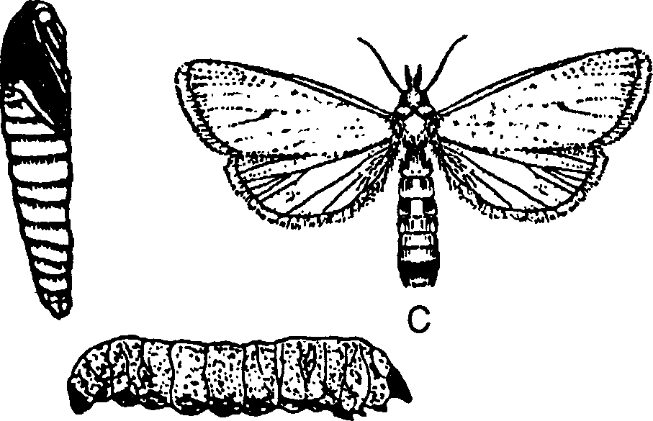

B

A

Fig. 1. The sugarcane top borer, *Scirpophaga excerptalis*

1. Larva B. Pupa C. Adult
2. **General Appearance**. Moths are silvery white in colour. Females are about 20-25 mm across the wings. The anal segment of female is covered with a tuft of yellow, orange or brownish silken hairs.

1. **Life cycle.** The female lays 300-500 elongated and oval eggs either singly or in clustures of 5- 10 on the lower side of the leaves. The clustures of eggs are covered with tuft of coloured hairs in which eggs can be easily seen in sun light.

The eggs hatch into larvae after 5- 10 days of incubation period. The newly hatched larvae, about 2 mm in size with black head and yellowish white in colour make its way to the top shoot of the cane through midrib of the leaf. It becomes full-grown passing through five instars within 35-45 days.

The full-grown larva, 30 mm in length, forms a characteristic chamber with an emergence hole just above the node. The hole is plugged with 4-5 membranous and circular septa. The larva pupates within this chamber.

The pupal stage ends in 7- 12 days thenafter adult moth emerges out and survives for 4-5 days. There are 5-6 generation in a year. The larvae of last generation do not pupate and undergo diapauses inside the top of the cane to pass the winter season in north India.

1. **Damage.** From March to September the damaging tendency of the pest is at its peak. Only the caterpillar is destructive. Upon hatching from the eggs, it makes hole in the midrib of leaves and then travels the central shoot and consumes the growing bud of the cane, thenafter it further bores upto 4-6 internodes of the top shoot. As a result, the upper part of the shoot dries up and charred forming 'dead-hearts '. First two generations infest young plants causing death of plant. Due to its infestation, not only the yield of the crop is highly decreased (up to20-30%) but the sugar content in the cane juice is also highly reduced.
2. **Control measures.**
3. The egg masses should be collected and destroyed early in the season, *i.e.,* April to May.
4. Resistant cultivars of the sugarcane should be planted such as Co 419, CoS 767, CoJ 67, Co 1 158.
5. Soil application of carbofuran at 2 kg a.i./ha or phorate at l kg a.i./ha is also recommended.
6. On severe infestation, malathion 50% EC, 1250 ml or endosulfan 35% EC 800 ml or pholithian 10% EC 300 ml/ha may be sprayed over the standing crops.
7. **Biological control** by release of a ichneumonid wasp *Isotima javensis* @ 125 females /ha in coastal area of Tamil Nadu and inundative release of a chalcid wasp *Trichogramma chilonis* @ 500 eggs/ha in Andhra Pradesh and northern India have been recommended.

-----------------------o----------------