**Dr.S.K.Tiwari,**

**Deptt. of Zoology, DDU Gorakhpur University, Gorakhpur**

**M.Sc. IV Semester Zoology (Entomology): Paper III (4103) Economic Entomology**

**­­­­­­­­­­­­____________________________________________________________________________________**

**Pests of Sugarcane**

**[ I] *Pyrilla perpusilla* (The Sugarcane Leaf Hopper)**

**Order: Hemiptera**

**Family:Lophopidae**

**1. Distribution**: The sugarcane leaf hopper, *Pyrilla perpusilla* is distributed throughout India where sugarcane is cultivated. It usually severely damages the cane in Uttar Pradesh, Bihar, Punjab, Madhya Pradesh and Maharastra. Outside India, it is reported from Sri Lanka, Republic of Myanmar and Thailand (Fig. 1).

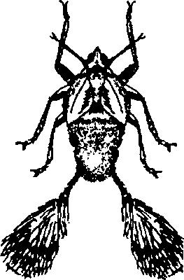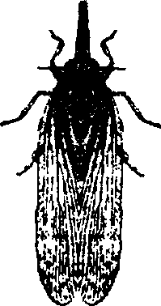 **2. Host Plants:** Sugarcane is the primary host of the pyrilla, however, the insect is able to thrive well on a variety of food plants such as wheat, barley, oat, maize, millets, paddy, wild grasses, etc. Occasionally, it is also seen in the fields of lady's finger, cucurbit vegetables, and certain legumes.

A Nymph B Adult

Fig 1. The sugarcane leaf hopper, *Pyrilla perpusilla.*

**3. General Appearance:** The straw-coloured adult insect has two pairs of wings which are folded on the abdomen in shape of a roof. The length of the body is about 8- 10 mm. They possess long pointed snout with prominent red eyes. The female has a pair of pads on the abdominal end of the body. The adults are very active flier.

**4.** **Life cycle.** Pyrilla breeds throughout the year. Female lays 300 to 500 eggs in large clusters each containing 10-65 eggs on lower surface of leaves during summers and inside the leaf sheaths during winter, which are covered with brown tuft of hairs in which eggs can be easily seen in sun light. The eggs are oval, shining and pale-white or greenish in colour.

Eggs hatch into nymph after 7 days in summer and 22 days in winter. The freshly hatched nymphs are cream coloured, soon turning into pale brown, and have a pair of characteri stics anal filaments. Nymphal period varies with climatic conditions. In summer it is about 6-8 weeks but in winter it is about 17-18 weeks as winter is passed in nymphal stage.

After five moults, the nymphs change into adults. Male survives for 5-7 weeks while females for 5-8 weeks. In monsoon, the life cycle is completed within 6-9 weeks. In a year, about 4 overlapping generations occur.

**5. Damage:** Both nymphs and adults suck cell sap of succulent leaves of sugarcane by their rostrum hence the leaves turn pale yellow and dry up. Pyrilla excretes a sweet sticky transparent liquid known as HONEY DEW onto foliage which attracts the harmful fungi resulting into good growth of ‘black sooty mould’ turning the leaves black thus photosynthesis is retarded affecting adversely the yield of the crop. Sugar content may decrease to 2-5% in infested crop. Additionally, if sown, such canes do not germinate properly. Most of the damage caused by the Pyrilla occurs during April to October.

**6. Control measures:** Following cultural practices should be employed to minimise the pyrilla attack on sugarcane:

1. Leaves having egg masses should be stick off from the plant and burnt.

**(ii)** The cane-trash should not be burnt after harvesting as it kills their natural enemies,

**(iii)** The amount of nitrogen fertiliser in soil should be kept moderate as high nitrogen content in soil makes the leaves succulent and attractive for the hoppers,

**(iv)** Resistant varieties of sugarcane should be planted.

**(v)** The ratoon crops should be avoided.

**(vi) Biological Control**: Its egg parasitoid, *Tetrastichus pyrillae* and the ectoparasitoid moth, *Epiricania melanoleuca* (15000 cocoons/ha) should be introduced in the infested fields.

**(vii)** If 20-30% nymphs and 40-60% adults are parasitised, application of any insecticide should be avoided.

**(viii)** If the crop is heavily infested before monsoon, endosulfan 35 EC @ 1 .5 ml/l of water should be sprayed.

(C) Pseudopupa. (0) Adult

-------------------------0----------------------