**Dr. S.K.Tiwari**

**Department of Zoology, DDU Gorakhpur University, Gorakhpur**

**B.Sc. II Year, Zoology Paper II- Vertibrate Zoology**

**__­­­____________________________________________________________**

**Arterial System of *Uromastix hardwickii* (Spiny tailed lizard)**

There are three aortic arches which arise independently from the ventricle, a little to the right of the middle line, viz., the pulmonary arch and a pair of systemic arches (right and left systemic arches).

**A. Pulmonary Arch:**

The pulmonary arch lies ventrally and arises from the right ventral side of the ventricle (cavum pulmonale). As it travels forwards, it curves and becomes dorsal to the left systemic arch, where it soon divides into right pulmonary and left pulmonary arteries going to the right and left lungs respectively.

**B. Systemic Arches:**

Both the systemic arches arise directly from the cavum dorsale of the ventricle carrying oxygenated blood. The left systemic arch is fully visible in the ventral view of the heart. It arises from the right side of the ventricle but curves later to the left and carries mixed blood. The point of origin of the right systemic arch is not visible from the ventral side but can be seen in the dorsal view.

The right systemic arch arises from the left side of the ventricle and lies dorsal to both the pulmonary and the left systemic arches. Later it curves to the right side. The two systemic arches communicate with one another by a foramen of Panizzae, situated where the arches cross each other anterior to the heart. Both the systemic arches then turn upwards, backwards and inwards and join posterior to the heart in the mid-dorsal line to form dorsal aorta.

The right systemic arch gives off a very short artery before it starts curving to the right in the notch between the two auricles which is called the carotis primaria or innominate artery. The right systemic arch also gives off a common subclavian artery before joining the left systemic arch.

**(a) Common Carotid Arteries:**

The innominate arises from the right systemic arch before curving to the right side. It bifurcates to form the right and left common carotid arteries. Each common carotid runs forward for some distance parallel to the systemic arch of its side and then divides into the external and the internal carotid arteries.

The external and the internal carotid arteries extend forwards through the neck, both of which branch into numerous arteries supplying oxygenated blood to the head anterior mesenteric region. Each internal carotid artery is connected with the systemic arch of its side by a vessel called the ductus caroticus.

It is a remnant of hypogastric embryonic lateral aorta. Since carotid arteries femoral arise from the right systemic arch, so they are also known as carotico-systemic arches. The ductus arteriosus or the ductus Botalli (which usually connects the pulmonary artery and the systemic arch) is absent in Uromastix hardwickii.

**[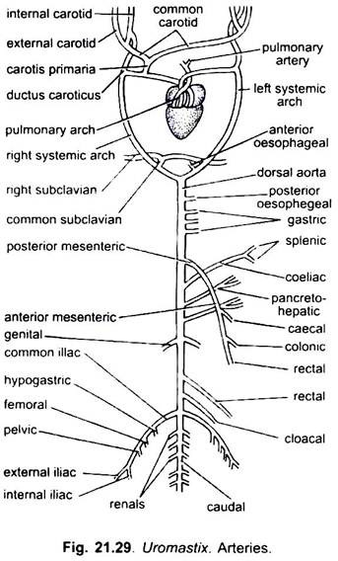](https://www.notesonzoology.com/wp-content/uploads/2017/07/clip_image011-2.jpg)**

**Fig 1.**

**(b) Common Subclavian Artery:**

It arises from the right systemic arch before it joins the left systemic arch. It soon divides into the right and the left subclavian arteries which run outwards to supply the respective forelimb. Each subclavian artery gives off three vessels, i.e., scapular to the scapular region, coracoid to the coracoid muscles and brachial to the arm.

**(c) Anterior Oesophageal Artery:**

The left systematic arch also gives off a small anterior oesophageal artery which supplies the anterior part of the oesophagus. Shah also described posterior oesophageal artery which arises from the dorsal aorta. However, Bhatia has figured only one oesophageal artery.

**Dorsal aorta:**

The dorsal aorta is formed by the union of the right and left systemic arches.

**It extends straight backwards in the mid-dorsal line beneath the vertebral column, giving off the following arteries:**

**(i) Posterior Oesophageal Artery:**

Immediately after the formation of the dorsal aorta a small unpaired artery arises from it which is called the posterior oesophageal artery. It supplies blood to the posterior part of the oesophagus.

**(ii) Gastric Arteries:**

Three small unpaired gastric arteries arise behind the posterior oesophageal artery. These arteries supply blood to the anterior, middle and posterior part of stomach and are called anterior, middle and posterior gastric arteries.

**(iii) Posterior Mesenteric Artery:**

The posterior mesenteric artery is large and unpaired, arises far forward at the level of the fifth parietal, just in front of the origin of coeliac. It runs backwards and distributes blood to the large intestine by three branches: the caecal, colic (colon) and rectal.

**(iv) Coeliac Artery:**

It arises behind the posterior mesenteric and runs forwards, crosses the posterior mesenteric and supplies blood to the spleen and to stomach by two branches, viz., the spleenic and gastric.

**(v) Pancreo-Hepatic Artery:**

It is a fairly large unpaired vessel supplying blood to the duodenum, liver and pancreas.

**(vi) Anterior Mesenteric or Intestinal Artery:**

It arises behind the pancreo-hepatic artery and supplies blood to the entire small intestine by a number of branches.

**(vii) Genital or Gonadial Arteries:**

These are paired, arise near the tenth parietal and supply blood to the gonads and suprarenal glands. They are called spermatic arteries in the male and ovarian arteries in the female.

**(viii) Rectal Artery:**

It is an unpaired artery, arises in between the thirteenth and fourteenth parietals. It passes down along the dorsal wall of the rectum and supplies blood to it.

**(ix) Cloacal Artery:**

It is an unpaired median artery which arises close to the common iliac arteries. It supplies blood to the lateral wall of the cloaca and the terminal portion of the rectum.

**(x) Common Iliac Arteries:**

A pair of large common iliac arteries arises near the middle region of the kidneys and enters the hindlimbs. Before entering the limbs, each common iliac artery gives off a hypogastric artery to the urinary bladder, a femoral artery to the thigh muscles and a pelvic artery to the pelvic girdle and the fat bodies. It supplies the hindlimbs by two branches, viz., external and internal iliac arteries.

**(xi) Renal Arteries:** Three pairs of small renal arteries supply blood to the kidneys.

**(xii) Caudal Artery:**

The posterior end of the dorsal aorta continues behind as the caudal artery. The caudal artery runs through the haemal canal of the caudal vertebrae.

**(xiii) Parietal Arteries:**

During its course, the dorsal aorta also gives off about 15 pairs of small parietal arteries, supplying blood to the trunk muscles and caudal muscles.

**The blood circulation in the body is as follows:**

**[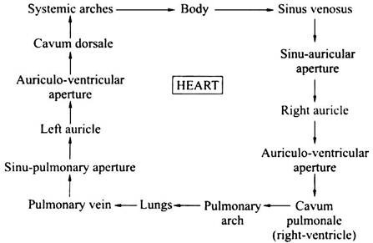](https://www.notesonzoology.com/wp-content/uploads/2017/07/clip_image009-1.jpg)**

-------------------------------o--------------------------