## Dr. S. K.Tiwari

## Zoology Department, DDU Gorakhpur University

## M. Sc. IV Semester Entomology

***Pectinophora gossypiella***

# Scientific Name

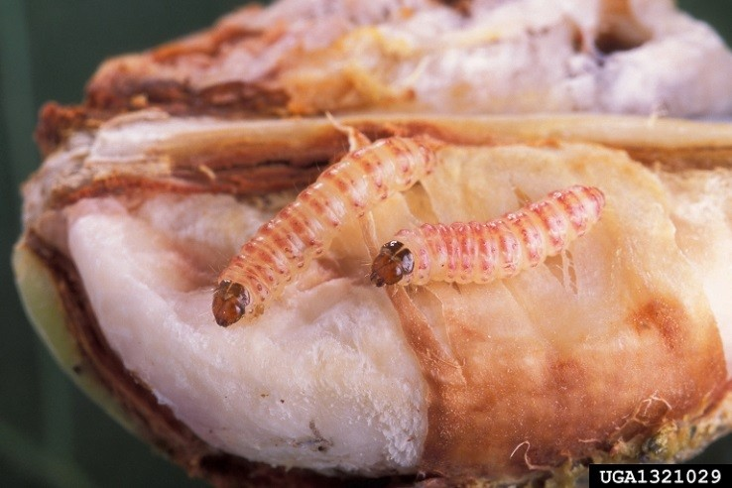

**Figure 1.** *P. gossypiella* larvae. Image courtesy of Peggy Greb, USDA Agricultural Research Service, [www.bugwood.org.](http://www.bugwood.org/)

*Pectinophora gossypiella* Saunders

## Synonyms:

*Depressaria gossypiella* Saunders *Ephestia gossypiella* Saunders *Gelechia gossypiella* Saunders *Gelechiella gossypiella* Saunders *Platyedra gossypiella* Saunders

# Common Name(s)

Pink bollworm

# Type of Pest

Moth

# Taxonomic Position

**Class**: Insecta, **Order**: Lepidoptera, **Family**: Gelechiidae

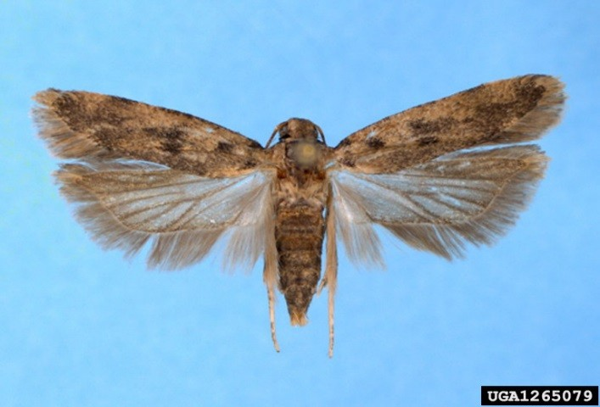

**Figure 2.** *P. gossypiella* adult.

# Pest Description

Eggs: Elongate oval, flattened; about 1 mm long and 0.5 mm broad (0.04 by 0.02 in.); the shell is pearly white, with a finely wrinkled surface. When newly laid, the egg has a slightly greenish tint. At maturity it turns reddish (Busck, 1917).

Larvae: The larvae (Fig. 1) are initially white with a dark head. The full grown larvae are 10 to 12 mm (0.39 to 0.47 in.) long and are white with a double red band on the upper portion of each segment .

Pupae: The pupa is 8 to 10 mm (0.31 to 0.39 in.) long, rather plump, reddish brown; posterior end pointed and terminating in a short, stout, upwardly turned hooklike cremaster; entire surface finely pubescent; no long setae, spines or hooks, except on last joint. When mature, the pupa becomes much darker; the imago's eyes can be seen prominently under the gena of the pupal skin, and the segmentation of the adult antennae and legs becomes discernible. Adults: Moths (Fig. 2) are brown with a wingspan of 15 to 20 mm (0.59 to 0.79 in).

*P. gossypiella* adults are small, dark-brown moths measuring about 12 to 20 mm (0.47 to 0.79 in) across the wings. The head is reddish brown in color with pale, iridescent scales. Antennae are brown and the basal segment bears a pecten of five or six long, stiff, hair-like scales. The labial palpi are long and curved upwards: the second segment bears a slightly furrowed hairy brush on the underside that becomes smooth distally and the terminal segment is shorter than the second. The proboscis is scaled.

Forewings are elongated-oval, pointed at the tips and bearing a wide fringe. The ground color of the forewings is brown and they have fine dark scales that form vague patches in the region of the medial cells and at the wing base. The apical portion of the wing is dark brown with a transverse, light-colored band. Sometimes the wing bears a round medial spot.

The hind wings are broader than the fore wings, trapezoidal in form and silvery gray with a darker, iridescent hind margin. The wing fringe is ochreous and darker at the base and apex.

Legs are brownish black with transverse, ochreous bands in the form of rings. The abdomen is ochreous toward the upper side, dark brown laterally and covered with ochreous-brown scales on the underside.

In the genitalia, the male uncus is broad at the base, tapering to a point and the aedeagus has a hooked tip. The female ovipositor is weakly sclerotized (CABI, 2010).

## Biology and Ecology

This species is adapted for areas with low rainfall and a long growing season .

Eggs are laid singly or in small batches on the green cotton boll, the calyx, or the flower; they are more commonly found on the apex of the green boll on the longitudinal depressions . Before bolls are present, eggs are laid singly on squares, stems, and terminal buds; bolls are preferred when present. One to four eggs per boll are commonly seen although as many as 20 can be found on one boll. Hatching occurs in four to six days. Females can lay approximately 300 eggs.

After hatching, the larva tunnels into the boll and begins feeding on the soft inner wall or the partitions of the boll. The larva will usually bore close to the apex and tunnel downward towards the bottom seeds. From here it begins partially feeding on seeds while moving back up towards the tip of the boll where it ends as a full grown larva. Feeding lasts 10 to 15 days . Development is completed in a single square or boll; larvae do not move between structures. If buds are less than 10 days old, larvae will die.

There are four instars total; only the last instar has the pink tint referred to in its common name. The larval period lasts 20 to 30 days during the summer and much longer during colder months. Overwintering occurs in the larval stage within the seeds , old bolls, leaf litter, or at gins or seed-storage facilities.

Pupation occurs in a spun cocoon within the seeds although larvae may pupate in the soil if disturbed . The pupal period lasts 10 to 20 days.

The adult is small and sluggish, hiding during the day mainly in ground cover. Flight occurs at dusk, with adults flying to the nearest cotton boll to mate and lay eggs. Mating can occur on the first night after emergence and can occur more than once. Although adults have the capability for strong flight, they usually only infest nearby or adjoining fields. Adults are too sluggish for sustained flight. Pre-oviposition is about two days.

After oviposition, the moths live from 1.5 to 2 weeks. Under favorable conditions, an entire life cycle can be completed in as little as 35 days. There may be four to six overlapping generations per year.

# Symptoms/Signs

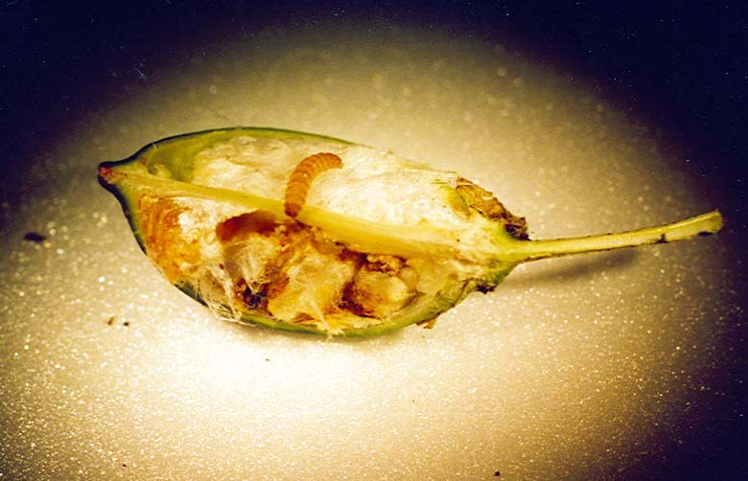

Entry holes made by *P. gossypiella* larvae are difficult to see. If opened, the caterpillars are easy to find (Fig. 3). Bolls damaged by the larvae fail to open completely. Other signs include fruit shedding, lint damage, seed loss, rotted bolls, and discolored lint or seed. Flowers may also be damaged .

Larvae may be hard to see at the early larval stages, but

**Figure 3.** *P. gossypiella* larva on a cotton boll with severe damage.

close examination may reveal the small entrance hole. The entrance hole may have a small amount of reddish frass, empty egg shells, or small larvae mining within the boll wall when dissected. Larval mines on the inner carpel wall can be seen from the outside. Also, a round exit hole about 2 mm (0.08 in.) in diameter can be found in the carpel.

The shell of the infested bolls will eventually become discolored taking on a reddish or black color. It should be noted that this discoloration may also occur from other injuries besides *P. gossypiella* and should not be used for definitive diagnosis.

In square infestations, the bloom is usually prevented from opening due to the larval webspinning. In boll infestations, older bolls (20+ days) are usually attacked; younger bolls will be attacked if older bolls are scarce or the *P. gossypiella* population is high. Younger bolls will have the greatest damage.

Larvae do not attack cotton leaves or shoots. Bud and flower damage only occurs early in the season.

# Pest Importance

*P*. *gossypiella* is currently found in almost all cotton growing countries of the world and is considered one of the most important economic pests in the world. In the United States, it attacks two cultivated crops, cotton and okra. Damage can reduce the lint yield by 50% and can lead to a decrease in seed oil.

As the larvae eat, they tunnel and soil the lint, which causes slowed growth of the cotton plant. The boll may then either rot or open prematurely and imperfectly. Un-infested parts of the boll will have slowed growth and the cotton lint will depreciate in value.

Boll feeding leads to reduction of quality of lint (discoloration, reduced fiber length, and strength) and seed. If damaged lint fibers are mixed with undamaged lint, it will reduce the average grade of the crop. It can also lead to reduced yield in weight in high infestations . Quantity of seed cotton can be reduced as well. Severe infestations can lead to crop loss.

# Known Hosts

The major host of *P. gossypiella* is *Gossypium hirsutum* (cotton). Other hosts include *Abelmoschus esculentus* (okra), other *Gossypium* spp. (cotton), *Gossypium tomentosum*, and *Hibiscus spp*.(rosemallows). Incidental hosts include species in the family Malvaceae.

Known Distribution

This pest has a large distribution throughout the world. It is thought to have originated in India.

----------------------0----------------------