***D*r. Shri Krishna Tiwari**

**Zoology Department**

**DDU Gorakhpur University**

*Tribolium species*

**Common name: Confused flour beetle  
Scientific name: *Tribolium confusum* Jacquelin du Val (Insecta: Coleoptera: Tenebrionidae)**

**Common name: Red flour beetle  
Scientific name: *Tribolium castaneum* (Herbst) (Insecta: Coleoptera: Tenebrionidae)**

[**Introduction**](http://entnemdept.ufl.edu/creatures/urban/beetles/red_flour_beetle.htm#intro)**-**[**Distribution**](http://entnemdept.ufl.edu/creatures/urban/beetles/red_flour_beetle.htm#dist)**-**[**Description and Life Cycle**](http://entnemdept.ufl.edu/creatures/urban/beetles/red_flour_beetle.htm#desc)**-**[**Habits**](http://entnemdept.ufl.edu/creatures/urban/beetles/red_flour_beetle.htm#habits)**-**[**Management**](http://entnemdept.ufl.edu/creatures/urban/beetles/red_flour_beetle.htm#management)

**Introduction** ;

Red and confused flour beetles attack stored grain products such as flour, cereals, meal, crackers, beans, spices, pasta, cake mix, dried pet food, dried flowers, chocolate, nuts, seeds, and even dried museum specimens. These beetles have chewing mouthparts, but do not bite or sting. The red flour beetle may elicit an allergic response, but is not known to spread disease and does not feed on or damage the structure of a home or furniture. These beetles are two of the most important pests of stored products in the home and grocery stores. The confused flour beetle apparently received this name due to confusion over about its identity as it is so similar to the red flour beetle at first glance.

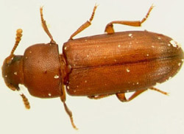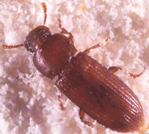

**Figure 1.** Dorsal view of an adult red flour beetle, Tribolium castaneum (Herbst) (left); and an adult confused flour beetle, Tribolium confusum Jacquelin du Val (right).

### Distribution

The red flour beetle is of Indo-Australian origin and is found in temperate areas, but will survive the winter in protected places, especially where there is central heat . In the United States, it is found primarily in the southern states. The confused flour beetle, originally of African origin, has a different distribution in that it occurs worldwide in cooler climates. In the United States it is more abundant in the northern states .

### Description and Life Cycle

Although small beetles, about 1/8 of an inch long, the adults are long-lived and may live for more than three years . 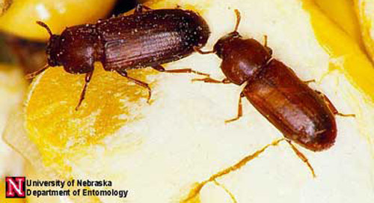

**Figure 2.** Adults of the confused flour beetle, Triboliumconfusum Jacquelin du Val, shown on a kernel of corn.

The red flour beetle is reddish-brown in color and its antennae end in a three-segmented club. Whereas the confused flour beetle is the same color but its antennae end is gradually club-like, the "club" consisting of four segments.

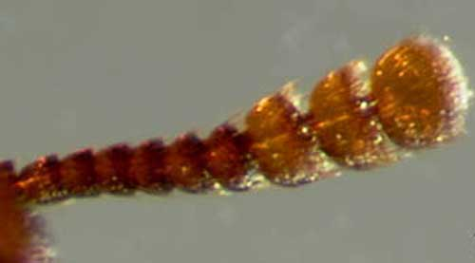

**Figure 3a.** Three-segmented antennal club of the adult red flour beetle, Triboliumcastaneum (Herbst).

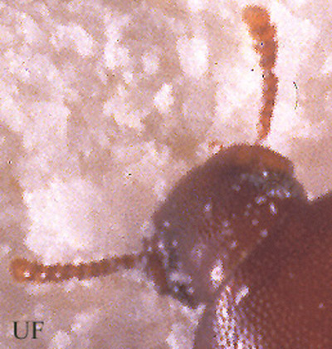

**Figure 3b.** "Four-segemented" or gradual club of an adult confused flour beetle, Tribolium confusum Jacquelin du Val.by

The head of the red flour beetle is visible from above, does not have a beak and the thorax has slightly curved sides. The confused flour beetle is similar, but the sides of the thorax are more parallel (Anonymous 1986).

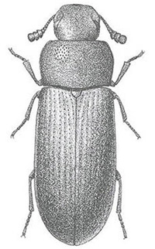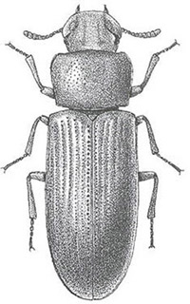

**Figure 4.** Comparison of adults of the red flour beetle (left), Tribolium castaneum (Herbst) and the confused flour beetle (right), Tribolium confusum (duVal). The antenna of the red flour beetle ends in a 3-segmented club and the sides of the thorax are slightly curved. The confused flour beetle has no apparent club on the antennae and the sides of the thorax are straighter. Graphics by USDA.

These two beetles are in the family Tenebrionidae and have a tarsal formula of 5-5-4 and notched eyes.

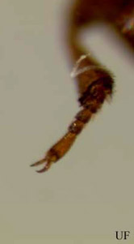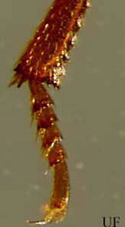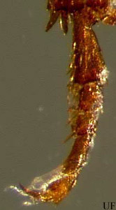

**Figure 5.** The front (left), middle (middle) and hind (right) legs of the red flour beetle, Tribolium castaneum (Herbst), showing the 5-5-4 tarsal formula. The confused flour beetle, Tribolium confusum Jacquelin du Val, has the same tarsel formula.

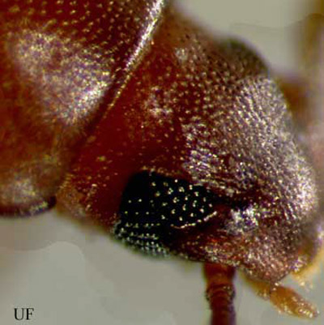

**Figure 6.** The head of a red flour beetle, Tribolium castaneum (Herbst), showing the notched eye. The confused flour beetle, Tribolium confusum Jacquelin du Val, also has the notched eye.

The red and confused flour beetles live in the same environment and compete for resources. The red flour beetle may fly, especially before a storm, but the confused flour beetle does not fly. Eggs, larvae, and pupae from both species are very similar and are found in similar environments. The eggs are white, microscopic and often have bits of flour stuck to their surface. The slender larvae are creamy yellow to light brown in color. They have two dark pointed projections on the last body segment.

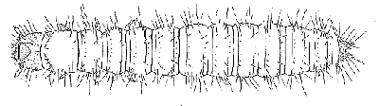

**Figure 7.** Flour beetle larva.

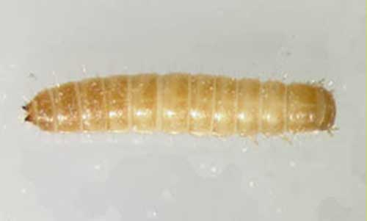

**Figure 8.** Larva of a flour beetle, Tribolium sp. Photograph by Rebecca

The pupae are lighter in color, being white to yellowish.

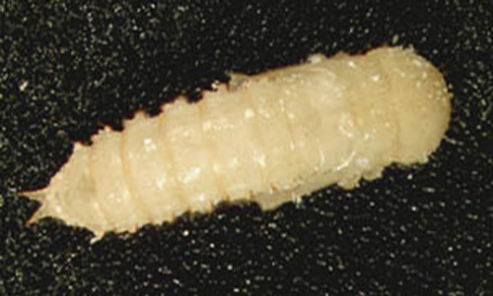

**Figure 9.**Pupa of a flour beetle, Tribolium sp. Photograph by Rebecca Baldwin,

These beetles can breed throughout the year in warm areas. The life cycle takes from 40 to 90 days, and the adult can live for three years. All forms of the life cycle may be found in infested grain products at the same time.

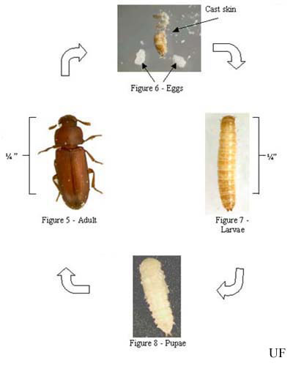

**Figure 10.** Life cycle of a flour beetle, Tribolium sp.

### 

### Habits

The red and confused flour beetles may be present in large numbers in infested grain, but are unable to attack sound or undamaged grain. The adults are attracted to light, but will go towards cover when disturbed. Typically, these beetles can be found not only inside infested grain products, but in cracks and crevices where grain may have spilled. They are attracted to grain with high moisture content and can cause a grey tint to the grain they are infesting. The beetles give off a displeasing odor, and their presence encourages mold growth in grain.

### Management

The first step in managing an infestation is to find and remove the source of the infestation (Koehler 2003). Flour beetles can feed and survive on even the smallest bits of grain, so cleaning is a crucial part of controlling these pests. When attempting to locate the source, be sure to consider all likely food items including, dry pet food, dried flowers, nuts, birdseed, and all grain products. Be sure to look for "leaky packages." Small bits of meal or grain spilling from a package are often a signal that an infestation is present (Arbogast et al. 2000). Be sure to locate all infested material and discard it by placing the material into a sealed bag or container and throwing it into an outside garbage container. You may also place the infested material into a freezer for four to five days. These beetles may survive freezer times shorter than this.

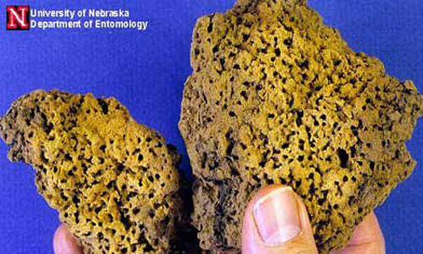

**Figure 11.** Damage caused by flour beetle (Tribolium sp.) infestation in flour.

Keep in mind that these beetles may infest areas other than the pantry. Be sure to inspect spices, pet food, and flower arrangements. Also keep in mind that some stuffing in furniture or stuffed animals may have natural products that these beetles could feed on. Also be aware of areas in which any of these products may have spilled, like under the refrigerator or stove. These beetles are able to locate very small bits of food. Once all of the infested material has been removed, be sure to vacuum and clean up the area around the infestation. If you have shelf paper, it would be wise to remove it, thoroughly clean under it with soap and hot water, and replace it with new paper. Be sure to pay close attention to the cracks and crevices of any cabinets. To prevent re-infestation, all grain products should be stored in containers with tight fitting lids, or stored in the freezer. Also consider where the infestation came from. It is likely that you could have a re-infestation by purchasing infested grain products from the same business. When shopping, look for those "leaky packages". If you suspect a beetle infestation, don't buy the product.