**Dr. Shri Krishna Tiwari**

**Zoology Department**

**DDU Gorakhpur University**

***Sitotroga cerealella***

***Sitotroga cerealella* (Angois grain moth) : Distribution, Nature of Damage and Life Cycle!**

**Systematic Position:**

Phylum – Arthropoda  
   
Class – Insecta

Order – Lepidoptera  
   
Family – Gelechiidae  
   
Genus – *Sitotroga*Species – *cerealella*

**Distribution:**

This pest is found in almost all parts of the world and is one of the most destructive to the unmilled grains. It is commonly called as “Angoumois grain moth” because it was first described in 1736 from Angoumois province of France. In America it is commonly called “Fly Weevil”. In Bengal it is known as ‘Survi’.

**Marks of Identification:**

The adult moth is small in size measuring 1/2 inch in wing span. They are grey or yellowish brown in colour, with satiny luster. It can be distinguished from other common moths infesting stored products by the narrow, pointed hind wings, bearing wide fringes of hairs.

**Nature of Damage:**

They cause serious destruction to paddy, jowar, wheat, barley and maize. Only whole cereals are attacked, greatest damage occurs in the upper layer grains in bags, bins etc. When the grains lies exposed or is kept in receptacles which are not full the infestation is high and damage is considerable.

Damage done to grain by this pest is always caused by the larvae. The larva bores its way into the grain. Owing to the small size of larva the hole made in grain is difficult to detect. It is often noticed that after the larva enters into the grain, it turns about and spins a silken web over the opening through which it has entered, thus making it even more difficult to locate the entrance hole once it is inside the grain, the larva eats out the kernel. The infected grains are hollowed out by the larvae and replaced by their excrement and webbing.

**[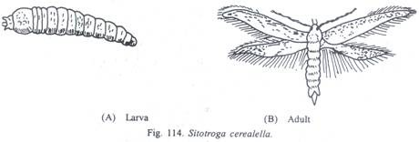](http://cdn.yourarticlelibrary.com/wp-content/uploads/2014/01/clip_image002127.jpg)**

Infestation starts in the field itself as damp grain is preferred for oviposition. The initial infestation takes place when the young grain is in or passing through the ‘milk stage’ in the field and usually a small percentage of grain kernels are infested in the beginning.

When the wheat is in the straw, it is easy for the moth to make their way from one wheat head to another as a result of which the infestation remains unchecked. By the time the grain is thrashed and stored, infestation by the moth increases rapidly. After the grain is thrashed and stored, it is impossible for the moths to make their way below the surface and infestation is restricted to the surface.

**Life Cycle:**

The moths a day after their emergence start mating. The female moth is capable of laying 150-400 eggs. These are deposited in depression, cracks, and crevices, in floor or holes in the grains. The eggs are white in colour when fresh, but soon become bright red in colour.

They are oval in shape and measures 0.5 mm in length, with both the ends rounded. The eggs hatch in about a week. The tiny caterpillar crawls about and penetrates the grain, effecting entrance generally through a crack or abrasion in the pericarp. It feeds on the kernel and remains there for the rest of its life.

The full grown caterpillar is about 5.0 mm long. It eats out a small channel to the outside of the seed leaving, however, a thin layer of the coat intact. A silken cocoon is spun, inside which reddish-brown pupa is formed. The larval stage lasts for 2-3 weeks. After one week of the pupation period, the young moth emerges through the thin seed-coat left by the caterpillar.

In this way, the larva and pupa are found entirely inside the grain. On an average the pest has 3-4 broods in a year, but sometimes 8 broods have also been reported. In store houses the pest breeds as long as the food supply lasts which may cover duration of several years. If the standing crop is not available the pest remain in the granary and breeds throughout the year.

**[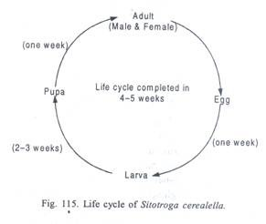](http://cdn.yourarticlelibrary.com/wp-content/uploads/2014/01/clip_image00451.jpg)**