**Dr. Shri Krishna Tiwari**

**Zoology Department**

**DDU Gorakhpur University**

**M. Sc. IV Semester Zoology**

**Comparative Vertebrate Anatomy**

**Skeletal Systems**

[**Bone**](http://www.ectsoc.org/reviews/011_roac.htm)**:**

* inorganic components of bone comprise 60% of the dry weight (largely calcium hydroxy-appetite crystals) &provide  the compressive strength of bone. The organic component is primarily collagen, which gives bone great tensile strength.
* provides support and movement via attachments for soft tissue and muscle, protects vital organs, is a major site for red marrow for production of blood cells, and plays a role in the metabolism of minerals such as calcium and phosphorus.
* There are two basic structural types of bone, compact and spongy. Compact bone forms the outer shell of all bones and also the shafts in long bones. Spongy bone is found at the expanded heads of long bones and fills most irregular bones. 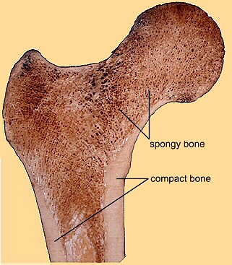

[Bone](http://education.vetmed.vt.edu/Curriculum/VM8054/Labs/Lab8/Lab8.htm) formation begins with a blastema (any aggregation of embryonic mesenchymal cells which will differentiate into tissue such as muscle, cartilage, or bone). These cells then develop into either FIBROBLASTS or OSTEOBLASTS. Fibroblasts form collagen; osteoblasts form bone cells. Together, these form MEMBRANE BONE (bone deposited directed in a blastema).

[**Intramembranous ossification**](http://education.vetmed.vt.edu/Curriculum/VM8054/Labs/Lab8/Examples/exmembos.htm)is the process of [membrane bone formation](http://www.douglas.bc.ca/ossification/files/ossification1.html). This process give rise to:

* bones of the lower jaw, skull, & pectoral girdle
* dentin & other bone that develops in the skin
* vertebrae in some vertebrates (teleosts, urodeles, &apodans)

[**Endochondral ossification**](http://www.bris.ac.uk/Depts/Anatomy/calnet/bones/page5.htm) is the process in which [bone is deposited in pre-existing cartilage](http://www.douglas.bc.ca/ossification/files/ossification2.html), & such bone is called REPLACEMENT BONE.

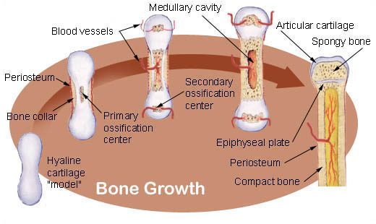  
Source: <http://training.seer.cancer.gov/module_anatomy/unit3_3_bone_growth.html>

**Skeletal elements:**

* Dermal skeleton
  + skin of most living vertebrates has no hard skeletal parts but dermal bone elements are usually present in the head region
  + early vertebrates (ostracoderms) had so much dermal bone they were called 'armored fishes'

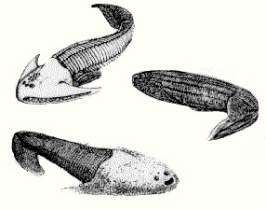  
Source: <http://www.auburn.edu/academic/classes/zy/0301/Topic3b/Topic3b.html>

* + after ostracoderms, fish continued to develop much bone in skin but that bone has become 'thinner' over time
* Endoskeleton
  + Somatic - [axial & appendicular skeletons](http://maxshouse.com/anatomy-sleleton.htm)
  + Visceral - cartilage or bone associated with gills & skeletal elements (such as jaw cartilages) derived from them

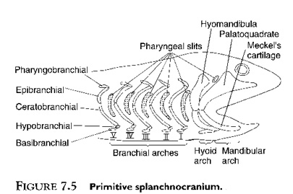  
Source: <http://www.auburn.edu/academic/classes/zy/0301/Topic11/Topic11.html>

**Dermal bone of fishes:**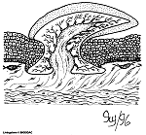

* Basic structure includes lamellar (compact) bone, spongy bone, dentin, &, often, a surface with a layer of enamel-like material
* Evolutionary 'trend' = large bony plates giving way to [smaller, thinner bony scales](http://www.amonline.net.au/fishes/students/scales/index.htm)
  + Ancient armor - not found on living fish
  + [Ganoid scales](http://www.amonline.net.au/fishes/students/scales/ganoid.htm) - found only on *Latimeria* (coelocanth) & sturgeons

[Placoid scales](http://www.amonline.net.au/fishes/students/scales/placoid.htm) - elasmobranchs (diagram to the right; pulp cavity > dentin layer > enamel)

[Ctenoid & Cycloid scales](http://www.amonline.net.au/fishes/students/scales/cyccten.htm) - modern bony fish

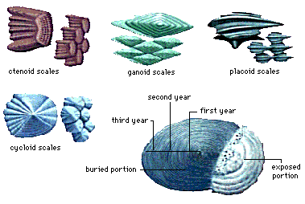  
Also check: <http://courses.washington.edu/vertebra/453/photos/skin_photos/special_integument1.htm>

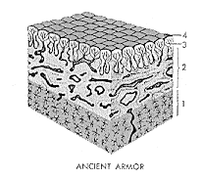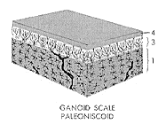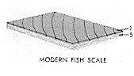  
1 = lamellar bone, 2 = spongy bone, 3 = dentin, 4 = enameloid, & 5 = fibrous plate (collagen)  
Source: <http://www.uta.edu/biology/restricted/3452int.htm>

Tetrapods - retain dermal elements in the skull, jaws, & pectoral girdle

**Somatic skeleton = axial skeleton (vertebral column, ribs, sternum, & skull) + appendicular skeleton**

**Vertebral column:**

[Vertebrae](http://www.auburn.edu/academic/classes/zy/0301/Topic8/Topic8.html) - consist of a centrum (or body), 1 or 2 arches, plus various processes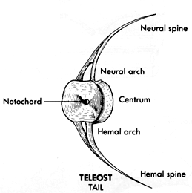

* [Amphicelous](http://www.auburn.edu/academic/classes/zy/0301/Topic8/Topic8.html#types)
  + concave at both ends
  + most fish, a few salamanders (*Necturus*), & caecilians

* Opisthocoelous
  + convex in front & concave in back
  + most salamanders
* Procelous
  + concave in front & convex in back
  + anurans & present-day reptiles
* Acelous
  + flat-ended
  + mammals
* Heterocelous
  + saddle-shaped centrum at both ends
  + birds

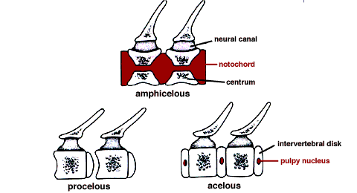

Vertebral arches:

* Neural arch - on top of centrum
* Hemal arch (also called chevrons) - beneath centrum in caudal vertebrae of fish, salamanders, most reptiles, some birds, & many long-tailed mammals

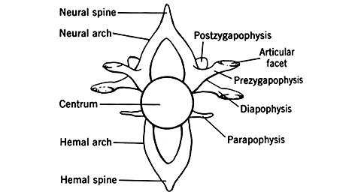

Vertebral processes:

* projections from arches &centra
* some give rigidity to the column, articulate with ribs, or serve as sites of muscle attachment

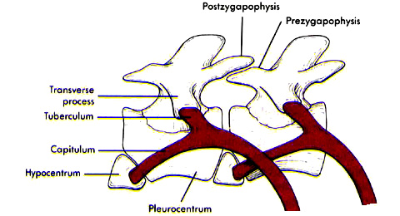

**Transverse processes** - most common type of process; extend laterally from the base of a neural arch or centrum & separate the epaxial & hypaxial muscles

**Diapophyses &parapophyses** - articulate with ribs

**Prezygapophyses (cranial zygapophyses) &postzygapophyses (caudal zygapophyses)** - articulate with one another & limit flexion & torsion of the vertebral column

**Vertebral columns:**

* Cartilaginous fishes
  + do not have typical fish vertebral columns
  + vertebrae include neural arches (cartilaginous dorsal plates) & dorsal intercalary plates are located between successive arches

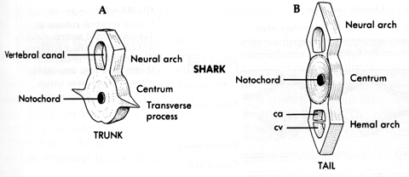

* [Teleosts](http://trc.ucdavis.edu/mjguinan/apc100/modules/Musculoskeletal/_index.html)
  + well-ossified amphicelous vertebrae
  + notochord persists within each centrum (but constricted)
  + neural arch associated with each centrum &hemal arches in tail (caudal) vertebrae

* Chondrosteans (sturgeons & paddlefish) & modern lungfishes
  + [incomplete centra](http://www.auburn.edu/academic/classes/zy/0301/Topic8/Topic8.html#parts)
  + notochord is not constricted
  + cartilage deposited in notochord sheath provides structural support

Diplospondyly = 2 centra and 2 sets of arches per body segment; occurs in some fish (including sharks)

Agnathans - only skeletal elements associated with the notochord are paired, lateral neural cartilages

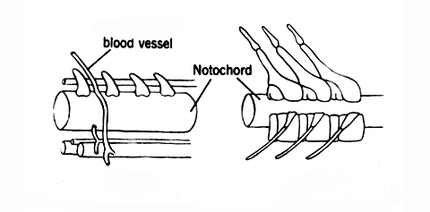

[**Vertebral columns**](http://www.crnasomeday.com/anatpages/spinal.htm)**of tetrapods**

* **Cervical region**
  + [Amphibians](http://campus.murraystate.edu/academic/faculty/terry.derting/anatomyatlas/boonewhitenecturusatlas.htm) - single cervical vertebra; allows little head movement
  + Reptiles - increased numbers of cervical vertebrae (usually 7) & increased flexibility of head
  + [Birds](http://www.biology.eku.edu/RITCHISO/554notes1.html) - variable number of cervical vertebrae (as many as 25 in swans)

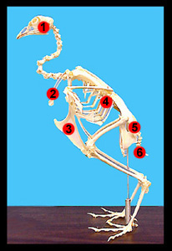

* + [Mammals](http://www.earthlife.net/mammals/skeleton.html) - [usually 7 cervical vertebrae](http://lamar.colostate.edu/~lctodd/cervical.htm)
  + Reptiles, birds, & mammals - 1st two cervical vertebrae are modified & called the [atlas & axis](http://tooldoc.wncc.nevada.edu/figure8.htm)
    - atlas - 1st cervical vertebra; ring-like (most of centrum gone); provides 'cradle' in which skull can 'rock' (as when nodding 'yes')
    - axis - 2nd cervical vertebra

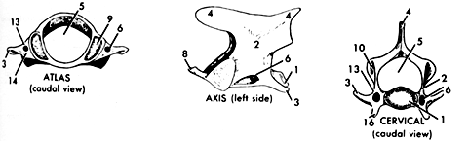

* + Transverse foramen (#6 in above caudal view of a cervical vertebra)
    - found in cervical vertebrae of birds & mammals
    - provides canal for vertebral artery & vein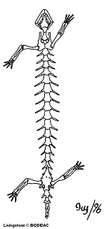

* **Dorsal region**
  + Dorsals - name given to vertebrae between cervicals&sacrals when all articulate with similar ribs (e.g., fish, amphibians, & snakes)
  + Crocodilians, lizards, birds, & mammals - ribs are confined to anterior region of trunk
    - [thoracic](http://lamar.colostate.edu/~lctodd/thoracic.htm) - vertebrae with ribs
    - [lumbar](http://lamar.colostate.edu/~lctodd/lumbars.htm) - vertebrae without ribs

* **Sacrum & Synsacrum**
  + sacral vertebrae - have short transverse processes that brace the pelvic girdle & hindlimbs against the vertebral column
    - Amphibians - 1 sacral vertebra
    - Living reptiles & most birds - 2 sacral vertebrae
    - Most mammals - 3 to 5 sacral vertebrae
  + [Sacrum](http://lamar.colostate.edu/~lctodd/sacrum.htm) - single bony complex consisting of fused sacral vertebrae; found when there is more than 1 sacral vertebra (see examples below):

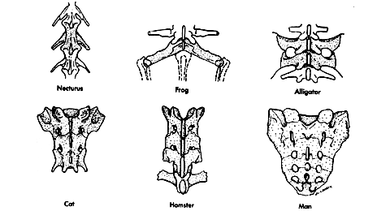

* + Synsacrum
    - found in birds
    - produced by fusion of last thoracics, all lumbars, all sacrals, & first few caudals
    - fused with pelvic girdle
    - provides rigid support for bipedal locomotion

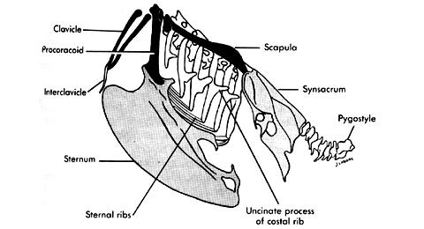

* **Caudal region**
  + Primitive tetrapods - 50 or more caudal vertebrae
  + Present-day tetrapods
    - number of caudal vertebrae is reduced
    - arches & processes get progressively shorter (the last few caudals typically consist of just cylindrical centra as shown below)
  + Anurans - unique terminal segment called the [urostyle](http://biology.nebrwesleyan.edu/Courses/Labs/Biology_of_Animals/Image%20Web%20Pages/Chordata/Frog_Skeleton.html) (section of unsegmented vertebral column probably derived from separate caudals of early anurans)
  + Birds - last 4 or 5 caudal vertebrae fused to form **pygostyle**(see drawing above)
  + Apes & humans - last 3 to 5 caudal vertebrae fused to form **coccygeal** (or [tail bone](http://www.bio.psu.edu/faculty/strauss/anatomy/skel/sacrum.htm))

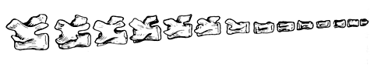

**EVOLUTION OF VERTEBRAE**

* Unlike most tetrapods today, vertebral column of earliest tetrapods did not consist of 1 bone/body segment.
* Crossopterygian vertebrae consisted of an hypocentrum (a large, wedge-shaped piece) plus 2 pleurocentra (smaller, intersegmental pieces). This type of vertebra is called a rachitomous vertebra.
* The 'trend' in vertebra evolution has been for pleurocentra to increase in size (and, of course, for the hypocentrum to decrease in size). This trend is apparent in this diagram:

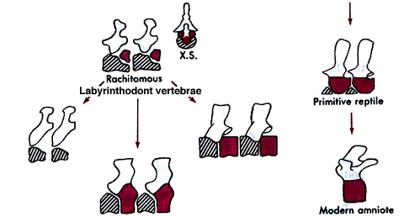  
Cross-hatched areas = hypocentrum; black areas = pleurocentrum.

**Ribs** - may be long or short, cartilaginous or bony; articulate medially with vertebrae & extend into the body wall

* A few teleosts - have 2 pair of ribs for each centrum of trunk (dorsal rib separates epaxial & hypaxial muscles)

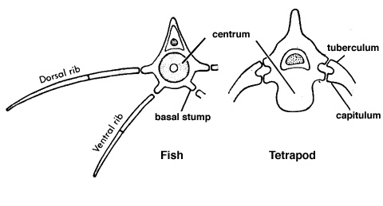

* Most teleosts-  ventral ribs only
* Sharks - dorsal ribs only
* Agnathans - no ribs
* Tetrapods - ribs usually articulate with vertebrae in moveable joints (see above drawing)
  + Early tetrapods - ribs articulated with every vertebra from the atlas to the end of the trunk
  + Later tetrapods - long ribs limited to thoracic region
    - Thoracic ribs - most composed of a dorsal element (vertebral rib) & a ventral element (sternal rib)
    - Sternal rib - may be ossified (birds) or remain cartilaginous (mammals); usually articulate with sternum (except ['floating ribs'](http://www.bio.psu.edu/faculty/strauss/anatomy/skel/skeletal.htm))
    - Uncinate processes - found in [birds](http://people.eku.edu/ritchisong/342notes2.htm#birds); provides rib-cage with additional support

**Sternum** - strictly a tetrapod structure &, primarily, an amniote structure.

* Amphibians - no sternum in early amphibians &, among present-day amphibians, only anurans have one
* Amniotes
  + sternum is a plate of cartilage & replacement bone
  + sternum articulates with the pectoral girdle anteriorly & with a variable number of ribs

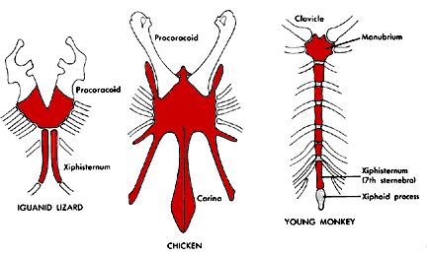

----------------------------------------------------O-----------------------------------------------------