**Dr. S. K. Tiwari**

**Department of Zoology**

**D.D.U. Gorakhpur University, Gorakhpur**

**M. Sc. Final Year (fourth semester) Entomology**

# Aerodynamics in birds : (Adaptation and mechanism)

**Introduction:**

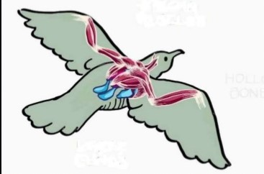Flight in bird is one of the most complex forms of locomotion in the animal kingdom. The flight of birds apparently seems to be simple; a bird lifts its body and drives itself forward by beating its wings against the air- current. But the process is not so easy. It involves many complicated and delicate steps. Pigeon, like other flying birds, is actually a living aero plane.

It applies all the aerodynamically principles of a plane and use the same mechanical equipment’s. In order to fly effi­ciently, the body of pigeon is built up in a spe­cial design. The details of flight mechanism are still incompletely known. However, the following account will give an idea.

Flight in birds includes hovering, taking off and landing which involves many complex movements. As different bird species have adapted to specific environments and other basic needs, they have developed different forms of wings and varied forms of flight.

**Major aerodynamic principle solved by the bird during flight:**

[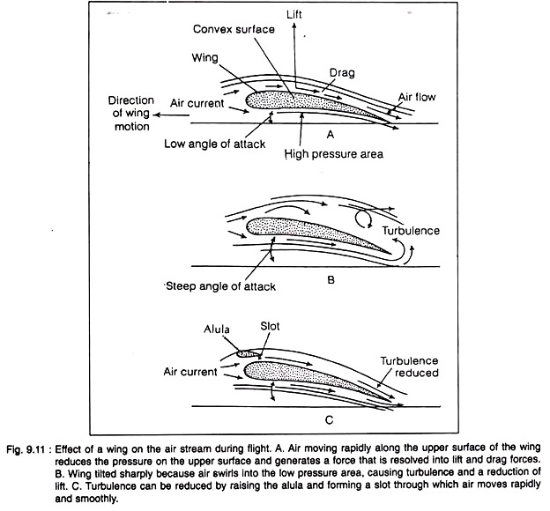](http://cdn.biologydiscussion.com/wp-content/uploads/2016/07/clip_image002-349.jpg)When our hand is stretched out from a running motor car or train, it is felt that the hand (which is slightly convex on the upper surface) is pushed upward and if the air-current is strong it can support the hand in air. This upward pushing is called lifting (Fig. 9.11 A).

If the air-current is not strong enough, then the drag (resistance to the motion of a body through air or water) of the centre of gravity will bring the object downwards. It means that in order to remain suspended in air, there must be enough force to negate the drag force and that must be proportional to the weight of the individual.

The same princi­ple is applicable to the flight of a bird. In pigeon, the forelimbs are modified as wings. These wings not only work as the surface where air-current acts to lift, but also are specially built to produce necessary air- current required for the lifting of the body.

Flight does not mean only the support of the body in air; together with lifting the bird will have to move forward. Both these func­tions during flight are carried out by wings — either by flapping or gliding. Of these two aspects of flight, lifting and moving forward, the bird spends more energy in the former than the latter.

**Perching mechanism:**

The hind limbs of pigeon are typically built on the reptilian plan. Pigeon, like other flying birds, has the ability to perch on the branches of the tree. Some muscles in the legs are modi­fied in such a fashion that the toes can close round the twig automatically when it sits on the tree. There are four digits in the hind limbs which are flexed by two sets of tendons. The tendon of the hallux arises from the flexor per­forans muscle (Fig. 9.12).

The tendons of the three forwardly directed digits are formed by the trifurcation of the tendon coming from per­oneus muscle. The tendons are so oriented that a pull upon any tendon flexes the toes.

When the bird settles on the branch of a tree, the legs are bent and they put the flexor tendons on the stretch. With the exertion of the pull, the toes are bent spontaneously around the perch. A bird can go to sleep in this position without any fear of falling off.

[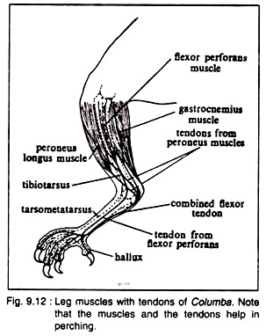](http://cdn.biologydiscussion.com/wp-content/uploads/2016/07/clip_image004-282.jpg)To unlock the feet, it is obligatory for the bird to raise its body to straighten the leg and loosen­ing the tendons which have been pulled tight over the ankle during perching. It is interesting to note that the foot contains no muscle, but the working of the digits is controlled by ten­dons coming from the muscles situated in the upper sector of the legs.

It has been claimed that some other mus­cles also assist in the process of perching. The role of ambiens (a thigh muscle originating from the pubis and travels along the entire length of the leg to join the muscles of the toes) in perching is a disputed issue.

**Chief modes of flight in birds:**

There are four main types of flight in birds and all the types may be used by the same bird at different times.

**1. Gliding or Skimming:**

The simplest mode of flight in birds is the gliding. After making rapid strokes some birds hold their wings motionless (spread) and glide for a considerable distance without flapping their wings.

This type of flight may be com­pared to coasting downhill on a bicycle. For gliding:

(i) The wings must be firmly braced to the body,

(ii) The elbow and wrist joints must be rigid,

(iii) The wings must present a rela­tively firm leading edge to the air.

(iv) By the initial flapping of the wings, the birds acquire the required momentum, and if the momen­tum is not produced from time to time, the birds lose height.

The gliding flight can only be exhibited for a short time and best seen in the gulls circling a moving ship in the sea for fish or scraps thrown overhead.

**2. Flapping flight:**

It is the most common type of flight and may be compared to swimming breast stroke. In this type the wings move upward and forward, downward and backward and then more rapid upward than downward.

The upstroke is very rapid but due to partial fold­ing of the wing curvature on the wing surface and the set of feathers, a minimum amount of resistance is created. The tips of wing do not work simply up and down but they, roughly describe a figure of 8.

In the down stroke (or power stroke), they move obliquely back­wards and downwards and their distal por­tions tilted upwards, thus it helps both to lift the bird and propel it forward. Before the beginning of the upstroke the elbow is flexed and in the upstroke the wings are partly folded.

[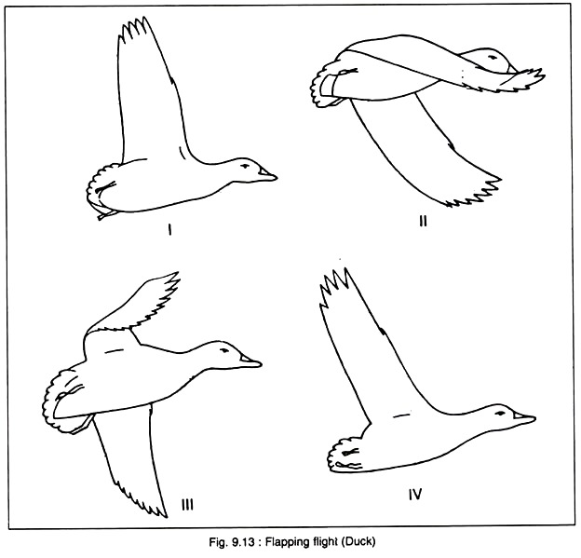](http://cdn.biologydiscussion.com/wp-content/uploads/2016/07/clip_image007-44.jpg)

[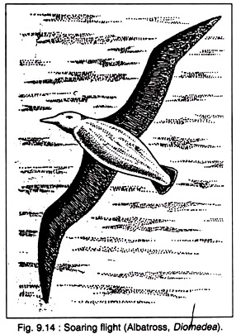](http://cdn.biologydiscussion.com/wp-content/uploads/2016/07/clip_image009-42.jpg)[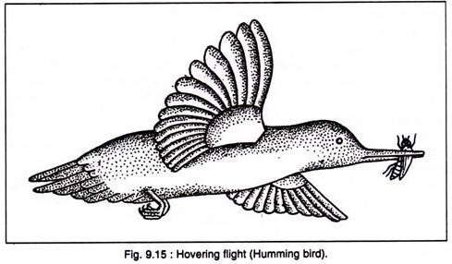](http://cdn.biologydiscussion.com/wp-content/uploads/2016/07/clip_image010-136.jpg)This type of flight is seen in duck (Fig. 9.13), crow and in other passerine birds. The wing beats vary according to the size of the bird and speed of flight. As a small bird sparrow has 13 strokes per second whereas in pelicans the stroke is 1-1.5 per second. Long pointed wings indicate strong sustained flight and are pos­sessed by swifts, falcons and pigeons and also other bird that take long journeys.

**Soaring flight:**

It is the most highly specialized and spec­tacular type of bird flight. The soaring flight of vultures, hawks, gulls, pelicans, falcon, stork, albatross (Fig. 9.14) and other birds was des­cribed in detail by Hawkins (1913). It consists of two phases — circling and gliding. In circling phase, the bird’s path consists of a series of cir­cles or loops with a continuous increase in height. The wings are fully extended and the tips of the primary feathers are widely separated.

Principles of Hawkins (1913) summarized by Cone in 1962.

(i) Soaring begins at a definite period of the day and is closely correlated with the intensity of sunshine.

(ii) The time of onset of wing depends on the wing loading, of the birds. The higher the wing loading, the greater is the height at which the birds soar.

(iii) In circling flight, the diameter of the circle increases with the wing loading.

[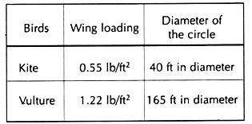](http://cdn.biologydiscussion.com/wp-content/uploads/2016/07/clip_image011-39.jpg)

**(iv) Hovering flight:**

The typical hovering flight of humming birds was described by Stolpe and Zimmer (1939). It probably represents the principles of active flight. In this flight the body becomes vertical and motionless. The wings beat down­wards and forwards during down stroke, back­wards and upwards during upstroke. The tips of the wings represent a figure of ‘8’.

The principle of the humming bird’s wing is essentially the same as that of a horizontal propeller blade of a helicopter. Hovering is best seen among humming birds (Fig. 9.15). Among Indian birds hovering is best seen among pied kingfisher and the kestrel, and among black winged kite and fish­ing eagles to a certain extent.

Flight Modifications in Pigeon:

Pigeon is a typical representative of flying birds. It is actually a ‘living airplane’. It flies in air by the same aerodynamically principles employed by a plane and utilizes similar ‘mechanical’ equipment’s, viz., wings, pro­pellers, steering gear, etc. for helping in taking off and landing.

This animal exhibits peculiar anatomical modifications for leading a life in air. It shows actually double adaptations— aerial and cursorial and or scansorial. As a consequence, the forelimbs have converted into the wings and the hind limbs have virtual­ly retained the reptilian plan and have under­gone less modification.

To fly in air, a heavier-than-air organism must possess the following unavoidable pre­requisites, without which Volant life becomes impossible.

**Flight adaptation and flight mechanism in birds**

**Adaptation:** Any alteration in the structure or function of an organism or any of its parts that results from natural selection and by which the organism becomes better fitted to survive and multiply in its environment is called as adaptation. Greater the degree of adaptation- more is the deviation from the normal morphology.

**Flight adaptation in birds**: For flight there are two types of adaptation in birds i.e., Morphological adaptations and Anatomical adaptations

1. **Morphological adaptations**: The following morphological adaptation in birds to help their flight such as-

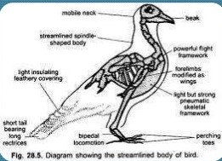

**Body contour:**

I. Spindle shaped body to ensure least wind resistance.

II. High position of light organs (lungs and air sacs) and low position of heavy muscles, sternum, digestive system.

III. Low Centre of gravity (average location of weight of an object.)

**Presence of feathers** 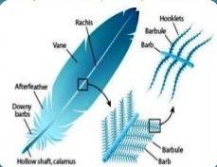

I. Makes the body stream-lined and reduces the friction to the minimum.

II. Very light, hardly adds weight to the bird.

III. Serves as a blanket enveloping air around the body and adds buoyancy.

IV. Feathers of wings increases the surface area for striking the air.

**Forelimbs modified into wings:** forelimbs becomes modified into unique and powerful propelling organs, which propel the body high up in the air.

**Mobile neck and beak:** modification of forelimbs is compensated by mobile neck and beak. enables the bird for feeding, nest-building, offence and defense, preening, etc.

**Bipedal locomotion:** hind limbs supports the body weight and acts as locomotory organs in the ground.

**Perching:** strongly developed muscles so modified that when a bird sits in a perch, the toes automatically grips the perch.

**Short tail and tail feathers:** These serve as a rudder during flight and assist in steering, lifting and counterbalancing.

[**2.**](https://image.slidesharecdn.com/flightadaptationandmechanisminbirdsinbrief-161207050613/95/flight-adaptation-and-mechanism-of-flight-in-birds-9-638.jpg?cb=1481087546)**Anatomical modifications:** There are following anatomical changes which help to flight to birds such as-

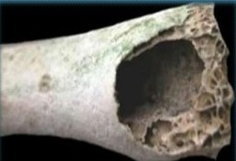**Endoskeleton:**

I. light and provides large surface for attachment of muscles. I

I. Bones are pneumatic filled with airspaces, the extension of air sacs. I

II. Skeletal framework is compact, centralized and relatively rigid due to fusion of bones.

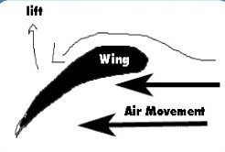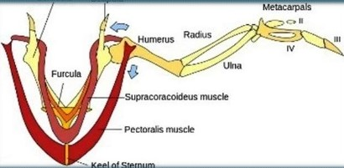**Muscles:** Muscles of flight muscles on the back are much reduced and flight muscles on the breast are strongly developed.

**Digestive organs:** digestive system is efficient, rectum reduced and never stores the undigested food because they cannot afford extra burden of faeces, hence is immediately got rid.

**Respiratory System:** Air in the bird respiratory system passes through in two breath cycles. • On the initial inhalation air is passed through straight ducts, the bronchi and mesobronchi, to posterior air sacs. • The following exhalation moves this air into the parabronchi of the lungs. • The second inhalation moves this air on into the anterior air sacs. The second exhalation then passes the air through the bronchi and out of the system.

**Circulatory system:** Heart is large and efficient complete separation of pure and impure blood.

**Reproductive system**: single ovary and an oviduct in female is a weight-reducing device.

**Airfoil:** The wings provide lift by creating a situation where the pressure above the wing is lower than the pressure below the wing. Since the pressure below the wing is higher than the pressure above the wing, there is a net force upwards. To create this pressure difference, the surface of the wing must satisfy one or both of the following conditions. The wing surface must be: • Cambered (curved); and/or • Inclined relative to the airflow direction.

**Lift:** Lift force is produced by the action of air flow on the wing, which is an airfoil. The lift force occurs because the air has a lower pressure just above the wing and higher pressure below.

**Gliding:** When gliding, birds obtain both, a vertical and a forward force from their wings. This is possible because the lift force is generated at right angles to the air flow. The lift force, therefore, has a forward component that counteracts drag.

**Drag:** Apart from its weight, there are three major drag forces that impede a bird’s aerial flight: frictional drag (caused by the friction of air and body surfaces), form drag (due to frontal area of the bird, also known as pressure drag), and lift-induced drag (caused by the wingtip vortices). These forces are reduced by streamlining the bird’s body and wings.

**Flapping:** When a bird flaps, its wings continue to develop lift, but the lift is rotated forward so providing thrust, which counteracts drag and increases its speed.

**Mechanism of flight**:

1. During flight the wings become unfolded, stretched and raised vertically upwards.
2. These then move downward and forward (down stroke) and finally upward and backward (up stroke).
3. Downstroke is achieved by the action of pectoralis minor,so that the wing is lowered down. The wing is raised by the contraction of pectoralis minor, and other muscles. During downstroke, the wing is thrust downwards like an oar impermeable to air. It moves forward and vertically upwards with little air resistance for the next powerful downstroke.
4. The body moves forward in upstroke.

Basic Mechanism of Flight
4/8/2019 Prof. Archana Das, Tangla College 13
GlidingWhen a bird is gliding, it doesn’t
have to ...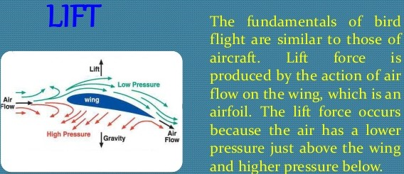

PERCHING MECHANISM
4/8/2019 Prof. Archana Das, Tangla College 17
Perching is actually
maintaining a typical
posture by the...4/8/2019 Prof. Archana Das, Tangla College 14
Basic Mechanism of Flight
Flapping
When a bird flaps, its wings continue to ...Basic Mechanism of Flight
4/8/2019 Prof. Archana Das, Tangla College 15
DragApart from its weight, there are 3
drag forces...

Perching Muscles
4/8/2019 Prof. Archana Das, Tangla College 18
 

4/8/2019 Prof. Archana Das, Tangla College 19
 