**Dr. Shri Krishna Tiwari**

**Zoology Department**

**DDU Gorakhpur University**

***Sitophilus oryzae***

**Pest of rice *(Sitophilus oryzae)*: Distribution, Life cycle,Nature of Damage and Control measures**

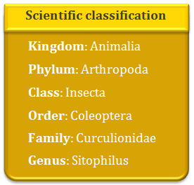

**Distribution**

Sitophilus Oryzae is also called as Rice weevils. These insects are cosmopolitan in distribution and have originated in Far East region. They can exist anywhere where physical conditions for growth are favourable and the grain is left undisturbed for some time.

**Habit and Habitat**

Sitophilus Oryzae is usually found in grain storages and processing plants. They infest wheat, oats, rye, barley, rice, and corn. Sometimes, they are also found infesting beans, sunflower seeds and dried corn. These insects do not bite nor damage wood.

**Identification**

Weevils have chewing type of mouthparts. The most significant identification feature of weevils is their snout, which is pretty long. The adult rice weevil is reddish-brown in color. It has irregularly shaped pits on its thorax, also four light spots are found on wing covers.

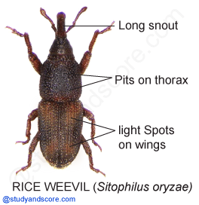

Rice weevils can fly. During larval stage they are legless, white to creamy white in color, with a small head. Weevils in the pupa stage have snouts just like the adults.

**Life Cycle of Rice weevil**

A single generation can be completed in 28 days. Rice weevils pretend death by drawing their legs close to body and remaining silent even when disturbed.

**Egg:** Rice weevil lays its eggs in crevices of kernels or dust. Female rice weevil lays about 4 eggs/day. During its life span of 5 months, it lays a total of about 250-400 eggs. The eggs hatch in 3 days.

**Larva:** They feed inside the grain kernel for 18 days. The larva is the only stage during which the insect grows. Inside the seed, its cuticle hardens and matures. It consumes several times its own weight and periodically moults to increase in size.

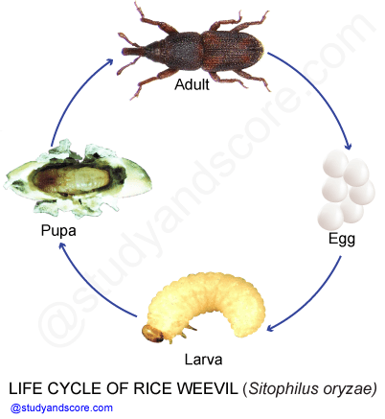

**Pupa:** The pupa stage lasts for 6 days. The pupa does not feed. In some species, the pupa is enclosed in a cocoon constructed by the larva. The pupa goes through great changes both internally and externally. Finally the insect emerges out as a developed adult.

**Adult:** Adults are between 0.1 and 1.7 cm long. They have three pairs of legs and their bodies are divided into head, thorax and abdomen. Adults move and penetrate deeply into bulk of grains and get widely distributed.

**\*** Head includes the mouth parts and sense organs

**\*** Thorax bears the legs and wings

**\*** Abdomen contains the reproductive organs

**Feeding habit and development of rice weevil**

Females drill a tiny hole in the grain kernel through whic it deposits its egg and then plugs the hole with a gelatinous substance. Inside the grain kernel, the egg hatches into a young larva which migrates toward the centre of the grain kernel. Now inside the grain the larva feeds, grows and develops into a pupa. The pupa undergoes major internal and external changes inside the grain to develop into an adult. The adult emerges out through the hole of emergence. The emerged adults are ready to mate and begin their generation.  .

**Damage caused by rice weevil**

Rice weevils are the most destructive pests of stored grain and they completely destroy the grain. Attack is evidenced by,

* Surface heating of grain
* Dampness which may even cause germination
* Presence of numerous adults

**Control measures to avoid rice weevil**

* Removal of infested food products
* Discarding heavily infested material
* Repackaging material into new infection-free containers
* Placing the products in the freezer for several weeks may help to kill adults and larvae