Dr. S. K. Tiwari
Department of Zoology
D.D.U. Gorakhpur University, Gorakhpur
M. Sc. Final Year (fourth semester) Entomology

Silkworm : (introduction, species, habit, habitat and biology)
Introduction:
A thin and continuous strands is called fiber. Which are of two types i.e., natural fiber and synthetic fiber. The fibers which are obtained from plants and animals are known as natural fibers e.g. cotton and silk while synthetic fibers are made by man e.g. nylon, polyester, etc. Silk is a type of natural fiber or animal fiber. Which is obtained from a number of insects commonly called silkworm in Hindi (Resham Ka Kira). Silkworm spins a continuous thin and tough strained called silk as its protective incrustation and it is reared to obtain silk.
Species of silkworm –
There are five major types of silk of commercial importance, obtained from different species of silkworms which in turn feed on a number of food plants: Except mulberry, other varieties of silks are generally termed as non-mulberry silks. India has the unique distinction of producing all these commercial varieties of silk.
Mulberry silkworm:
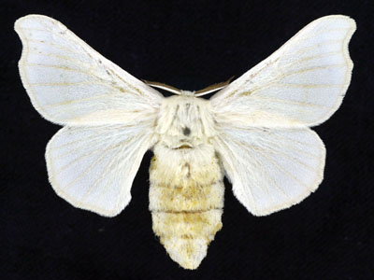
The bulk of the commercial silk produced in the world comes from this variety and often silk generally refers to mulberry silk. Mulberry silk comes from the silkworm, Bombyx mori L. which solely feeds on the leaves of mulberry plant. These silkworms are completely domesticated and reared indoors. In India, the major mulberry silk producing states are Karnataka, Andhra Pradesh, West Bengal, Tamil Nadu and Jammu & Kashmir which together accounts for 92 % of country's total mulberry raw silk production
Tasar silkworm:

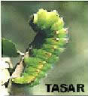
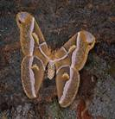
Tasar (Tussah) is copperish colour, coarse silk mainly used for furnishings and interiors. It is less lustrous than mulberry silk, but has its own feel and appeal. Tasar silk is generated by the silkworm, Antheraea mylitta which mainly thrive on the food plants Asan and Arjun. The rearings are conducted in nature on the trees in the open. In India, tasar silk is mainly produced in the states of Jharkhand, Chattisgarh and Orissa, besides Maharashtra, West Bengal and Andhra Pradesh. Tasar culture is the main stay for many a tribal community in India.
Oak Tasar silkworm:

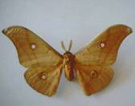
It is a finer variety of tasar generated by the silkworm, Antheraea proyeli J. in India which feed on natural food plants of oak, found in abundance in the sub-Himalayan belt of India covering the states of Manipur, Himachal Pradesh, Uttar Pradesh, Assam, Meghalaya and Jammu & Kashmir. China is the major producer of oak tasar in the world and this comes from another silkworm which is known as Antheraea pernyi.
Eri silkworm:

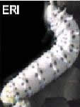
Also known as Endi or Errandi, Eri is a multivoltine silk spun from open-ended cocoons, unlike other varieties of silk. Eri silk is the product of the domesticated silkworm, Philosamia ricini that feeds mainly on castor leaves. Ericulture is a household activity practiced mainly for protein rich pupae, a delicacy for the tribal. Resultantly, the eri cocoons are open-mouthed and are spun. The silk is used indigenously for preparation of chaddars (wraps) for own use by these tribals. In India, this culture is practiced mainly in the north-eastern states and Assam. It is also found in Bihar, West Bengal and Orissa
Muga silkworm:

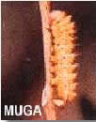
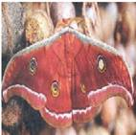
This golden yellow colour silk is prerogative of India and the pride of Assam state. It is obtained from semi-domesticated multivoltine silkworm, Antheraea assamensis. These silkworms feed on the aromatic leaves of Som and Soalu plants and are reared on trees similar to that of tasar. Muga culture is specific to the state of Assam and an integral part of the tradition and culture of that state. The muga silk, an high value product is used in products like sarees, mekhalas, chaddars, etc.

Type of silk | Type of Silk insects | Food plants
Mulberry | Bombyx mori | Moras alba (Mulberry)
 | Antheraea mylitta | Terminalia arjuna (Arjun)
Tasar | Antheraea paphia | Terminalia tomentosa (Asan)
 | Antheraea royeli  Antheraea pernyi  Antheraea proyeli | Sorea robusta (Sal)  Zizyphus jujuba (Plum) etc.
Eri | Attacus ricini | Ricinus communis (castor)
Munga | Antheraea assama | Tetraanthera monopetala  (Som), Michalia oblonga (champa), Listea citrata(Moyankuri)

Mulberry Silkworm: (History, Habit, Habitat and Life Cycle)

History of Mulberry Silkworm:
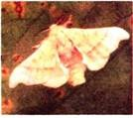
It is popularly popularly known as mulberry silkworm because it feed on mulberry (Morus alba) leaves or Chinese silkworm because its native place is China. The silk obtained from it is called mulberry silk it produces good quality of silk of all silk producing moth. The importance of silkworm in silk production was known in China during 3500 B.C. The Chinese people knew the methods for cultivating silk and of preparing cloth from it for more than 2000 years. The rearing of silk moth and production of raw silk is known as sericulture.
The art of sericulture was held by Chinese a very close secret, so much so, that the leakage of any information or attempt to export eggs or living cocoons was punishable with death. Even then silk was after all introduced in Europe by two monks, who were sent to China as spies.
They studied the nature, source and art of silkworm rearing and stealthily carried some eggs in their pilgrim’s staff to Constantinople in 555 A.D.
From this place the silkworm-rearing was spread into the Mediterranean and Asiatic countries including India, Burma, Thailand and Japan. The insect breeders have produced many races of silkworm moth by hybridisation to meet the requirements of climate, rapidity of reproduction, quality, colour and yield of silk.

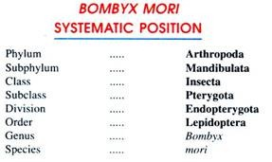

Habit and Habitat:
Bombyx mori or the Mulberry silkworm is completely domesticated organism and is never found wild. The adult moths seldom eat and are primarily concerned with reproduction.
Their larvae are voracious eaters. They feed on the leaves of mulberry trees. Some moths are single brooded or univoltine and others are many brooded or multivoltine. Owing to domestication, a large number of strains have evolved out, which produce cocoons of various shapes, sizes, weights and colours ranging from white to yellow.
Only one generation is produced in one year by worms in Europe and other countries where the length of winters far exceeds the duration of summers. Some strains pass through two to seven broods and are cultivated in warm climates. In South India, particularly Mysore, Coimbatore and Salem, a strain which produces several generations, extensively utilised to produce silk.

External Morphology:
The adult moth is about 25.00 mm long with a wing-span of 40.00 to 50.00 mm. The female silk moths are larger than the males. The moth is quite robust and creamy-white in colour. The body is distinctly divisible into three regions, namely head, thorax and abdomen.
The head bears a pair of compound eyes, a pair of branched or feathery antennae and the mouth parts. The thorax bears three pairs of legs and two pairs of wings. The cream-coloured wings are about 25.00 mm long and are marked by several faint or brown lines. The entire body is covered by minute scales.

Biology of Mulberry Silkworm:
The silk moth is dioecious, i.e., the sexes are separate. Fertilisation is internal, preceded by copulation. The development includes a complicated metamorphosis. The life cycle of silk moth starts when a female silk moth lays eggs. The caterpillar or larvae are hatched from the eggs of the silk moth. The silkworms feed on mulberry leaves and give rise to pupa. In pupa stage, a weave is netted around by the silkworm to hold itself. After that it swings its head, spinning a fiber made of a protein and becomes a silk fiber. Several caterpillars form a protective layer around pupa and this covering is known as the cocoon. The silk thread (yarn) is obtained from the silk moth’s cocoon. The life cycle of silkworm is explained below in details.

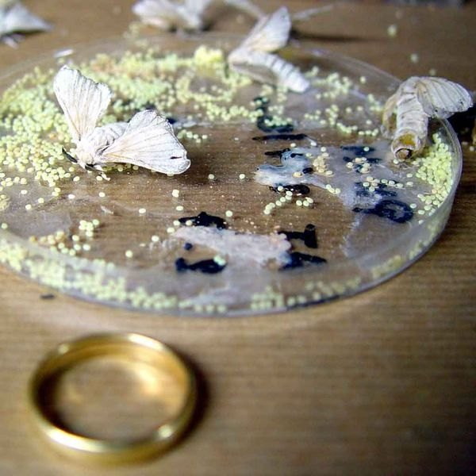
Eggs:
After fertilisation, each female moth lays about 300 to 400 eggs. These eggs are placed in clusters on the leaves of mulberry tree. The female covers the eggs by a gelatinous secretion which glues them to the surface of the leaves. The eggs are small, oval and usually slightly yellowish in colour. The egg contains a good amount of yolk and is covered by a smooth hard chitinous shell.
After laying the eggs the female moth does not take any food and dies within 4-5 days. In the univoltine (a single brood per year) they may take months because overwintering takes place in this stage but the multivoltine broods come out after 10-12 days. From the egg hatches out a larva called the caterpillar.
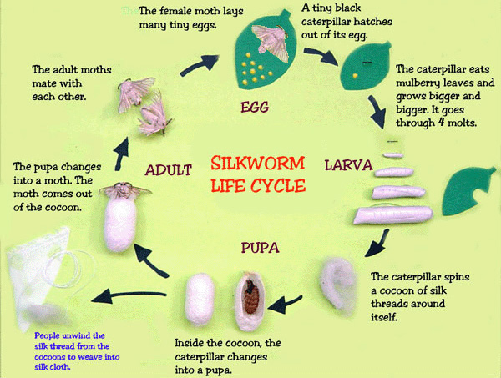

Life-Cycle of a Silkworm

Eggs | 10-25 days
Lava and worms | 20-33 days
Pupa | 10-14 days
Moth | 5-10 days

Larva:
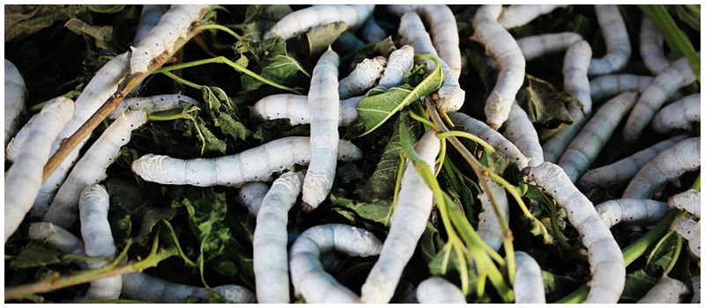
The larva of silkworm moth is called caterpillar larva. The newly hatched larva is about 4.00 to 6.00 mm in length. It has a rough, wrinkled, hairless and yellowish white or greyish worm-like body. The full grown larva is about 6.00 to 8.00 cm in length. The body of larva is distinguishable into a prominent head, distinctly segmented thorax and an elongated abdomen. The head bears mandibulate mouth and three pairs of ocelli.
A distinct hook-like structure, the spinneret, is present for the extrusion of silk from the inner silk-gland. The thorax forms a hump and consists of three segments. Each of the three thoracic segments bears pair of jointed true legs. The tip of each leg has a recurved hook for locomotion and ingestion of leaves.
The abdomen consists of ten segments of which first nine are clearly marked, while the tenth one is indistinct. The third, fourth, fifth, sixth and ninth abdominal segments bear ventrally a pair of un-jointed stumpy appendages each.
These are called pro-legs or pseudo-legs. Each leg is retractile and more or less cylindrical. The eighth segment carries a short dorsal anal horn. A series of respiratory spiracles or ostia are present on either lateral side of the abdomen.
The larva is a voracious eater and strongly gregarious. In the beginning chopped young mulberry leaves are given as food but with the advancement of age entire and matured leaves are provided as food. The caterpillar moves in a characteristic looping manner. The larval life lasts for 2-3 weeks. During this period the larva moults four times.
After each moult, the larva grows rapidly. A full-grown larva is about 8.00 cm long and becomes transparent and golden brown in appearance. A pair of long sac-like silk-glands now develops into the lateral side of the body. These are modified salivary glands.

Pupa:
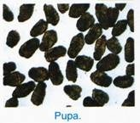
The full-grown larva now stops feeding and hides itself in a corner under the leaves. It now begins to secrete the clear and sticky fluid of its salivary glands through a narrow pore called the spinneret situated on the hypo pharynx. The sticky substance turns into a fine, long and solid thread or filament of silk into the air.
The thread becomes wrapped around the body of the caterpillar larva forming a complete covering or pupal case called the cocoon. The cocoon-formation takes about 3-4 days. The cocoon serves a comfortable house for the protection of the caterpillar larva for further development.

Cocoon :
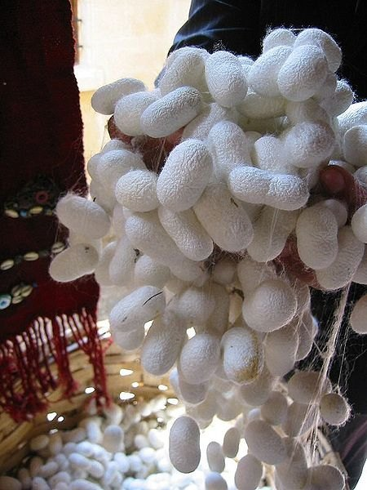
The cocoon is a white or yellow, thick, oval capsule which is slightly narrow in the middle.
It is formed of a single long continuous thread. The outer threads, which are initial filaments of the cocoon, are irregular but the inner ones forming later the actual bed of the pupa, is one long continuous thread about 300 metres in length, wound round in concentric rings by constant motion of the head from one side to the other about 65 times per minute.
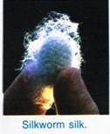
The irregular surface threads are secreted first and the inner continuous thread later. The silk thread is secreted at the rate of 150 mm per minute. Within a fortnight the caterpillar larva transforms into a conical brownish creature called the pupa or the chrysalis.
The pupa lies dormant, but undergoes very important active changes which are referred to as metamorphosis. The larval organs such as abdominal pro-legs, anal horn and mouth parts are lost. The adult organs such as antennae, wings and copulatory apparatus develop. The pupa finally metamorphoses into the imago or adult in about 2-3 weeks time.

Imago or Adult:
The adult moth emerges out through an opening at the end of the cocoon in about 2 to 3 weeks time, if allowed to live. Immediately before emergence, the pupa secretes an alkaline fluid, that softens one end of the cocoon and after breaking its silk strands, a feeble crumpled adult squeezes its way out. Soon after emergence, the adult silk moths mate, lay eggs and die.

Economic Importance of Mulberry Silkworm:

The mulberry silkworm moth is a very useful and valuable insect. It provides two very important products such as silk and gut to the mankind.

1. Silk:
The true silk of commerce is the secretion of the caterpillars of silkworm moth. Silk is a secretion in the form of fine threads, produced by caterpillars in preparing cocoons for their pupae. Long sac-like silk- glands, which are, in fact, modified salivary glands, secrete a thick pasty substance, which is passed out through a pair of fine ducts that open on the lower lip.
This secretion is spun by the caterpillar into fine threads which harden on exposure to air to form fairly strong and pliable silk-strands. The caterpillar larva prepares silk filaments several thousand metre in length at the rate of 15.00 cm per minute.

2. Gut:
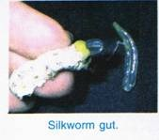
Another economic value of the silkworm is the preparation of gut used for surgical and fishing purposes. For preparing the gut, the intestines of silkworms are extracted, made into strings, dried, treated and packed. This industry has good prospects and is growing in Italy, Spain, Formosa, Japan and India.

Diseases in Silkworms:
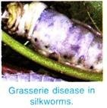
Silkworms suffer form several diseases. Chief of these is pebrine caused by a protozoan parasite Nosema bombycis of the microsporidian group.
In this disease the caterpillars turn pale brown and later on shrink and die. This disease is highly infectious, transmittable through eggs and responsible for very heavy economic losses. The control is brought about by a microscopic examination of the body fluids of the female, in which the parasites (pebrine corpuscles) are met with.
The eggs may be discarded or retained according to the presence or absence of parasites. Other diseases are fletcherie and grasserie but of minor importance. Sometimes caterpillars exhibit symptoms like jaundice disease, i.e., losing appetite, showing irregular growths, etc.

