Dr. S. K. Tiwari

Zoology Department, DDU Gorakhpur University

M.Sc.IV SemesterZoology

Comparative Vertebrate Anatomy

Digestive System

**Digestive tract** ­ ‘tube’ from mouth to vent or anus that functions in: ingestion

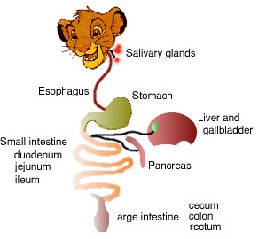digestion absorption egestion

**Major subdivisions** include the oral cavity, pharynx, esophagus, stomach, small & large intestines, and cloaca. **Accessory organs** include the tongue, teeth, oral glands, pancreas, liver, & gall bladder.

**Differences** in the anatomy of vertebrate digestive tracts is often correlated with the nature & abundance of food:

readily absorbed (e.g., hummingbirds) vs. requiring extensive enzymatic activity (e.g., carnivores)

constant food supply (e.g., herbivores) vs. scattered supply (e.g., carnivores)

The **embryonic digestive tract** of vertebrates consists of 3 regions: 1 ­ midgut ­ contains yolk or attached yolk sac

2 ­ foregut ­ oral cavity, pharynx, esophagus, stomach, & small intestine 3 ­ hindgut ­ large intestine & cloaca

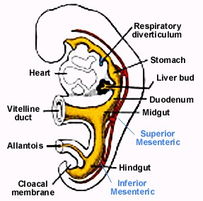

**Mouth & oral cavity.** The oral cavity begins at the mouth & ends at the pharynx. Fish have a very short oral cavity, while tetrapods typically have longer oral cavities. The mammalian mouth is specialized to serve as a suckling and masticatory organ (with muscular cheeks).

Palate = roof of the oral cavity

primary palate ­ internal nares lead into the oral cavity anteriorly

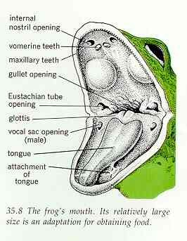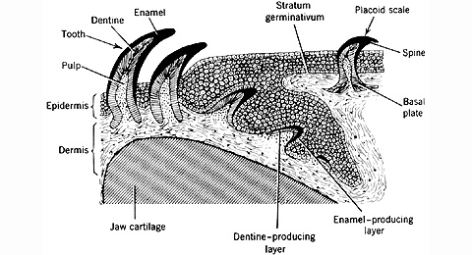

secondary palate ­ nasal passages are located above the secondary palate and open at the end of the oral cavity

**Teeth** are derivations of dermal armor.

Placoid scales ­ show gradual transition to teeth at the edge of the jaw

Composition of teeth ­ primarily dentin surrounded by enamel

Vary among vertebrates in number, distribution in the oral cavity, degree of permanence, mode of attachment, & shape

Toothless vertebrates are found in every class of vertebrates and include agnathans, sturgeons, some toads, turtles, birds, & [baleen whales](http://www.whalecenter.org/album/album27.htm).

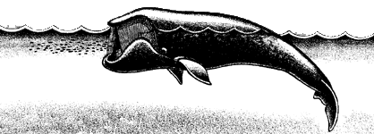

Toothed vertebrates:

A right whale swims at or near the surface of the water with its mouth open.

Water and food enter through a gap in the front baleen plates, and food is caught in the matted baleen fringes inside.

[Fish](http://www.meer.org/general-fish-teeth-gills.htm) ­ teeth are numerous & widely distributed in the oral cavity & pharynx

Early tetrapods ­ teeth widely distributed on the palate; most amphibians & some reptiles still have teeth on the vomer, palatine, & pterygoid bones

Crocodilians, toothed birds, & mammals ­ teeth are limited to the jaws

# TEETH:

1. ­ have tended toward reduced numbers & distribution
2. ­ most vertebrates (through reptiles) have succession of teeth
3. ­ most vertebrates (except mammals) replace teeth in ‘waves’ (back to front; every other tooth) 4 ­ mammals generally develop 2 sets of teeth: milk (deciduous) teeth & permanent teeth

# Morphological variation in teeth:

vertebrates other than mammals ­ all teeth are shaped alike ([homodont dentition](http://www.flmnh.ufl.edu/natsci/herpetology/brittoncrocs/!amis18.htm))

mammals ­ teeth exhibit morphological variation: incisors, canines, premolars, & molars (heterodont dentition)

incisors = cutting

canines = piercing & tearing premolars & molars = macerating

# Tongue:

Gnathostome fish & primitive amphibians ­ tongue is a simple crescent­shaped elevation in the floor of the oral cavity caused by the underlying hyoid skeleton & is called the primary tongue

Most amphibians ­ primary tongue (or hypobranchial eminence) + glandular field (or tuberculum impar) ('stuffed' with hypobranchial musculature)

Reptiles & mammals ­ primary tongue + glandular field (or tuberculum impar) + lateral lingual swellings (more hypobranchial muscle)

Birds ­ lateral lingual swellings are suppressed & intrinsic muscle is usually lacking

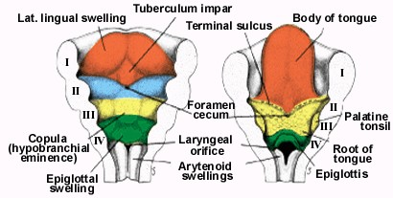

# Tongue mobility:

Turtles, crocodilians, some birds, & whales ­ tongue is largely immobilized in the floor of the oral cavity & cannot be extended

Snakes, insectivorous lizards & [amphibians](http://www-biol.paisley.ac.uk/courses/Tatner/biomedia/pictures/frogf.htm), & some birds ­ tongue sometimes long and may move in and out of the oral cavity (see<http://www.autodax.net/feedingmovieindex.html>)

Mammals ­ tongue is attached to the floor of the oral cavity (via the frenulum) but can still be extended out of the oral cavity

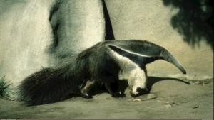

Using a keen sense of smell, [anteaters](http://www.arkive.org/species/GES/mammals/Myrmecophaga_tridactyla/Myrmecophaga_tridactyla_08.html?movietype=qtSmall) are able to effectively track down

ant nests on the forest floor. Once a nest is found, the mammal usually rips it open with its sharp foreclaws to expose its delectable contents. The anteater then proceeds to

catch and eat the ants by repetitively flicking its long sticky tongue in and out of the nest.

The giant anteater's unique tongue can measure as long as two feet (60 cm).

# Functions of vertebrate tongues:

capturing & gathering food (see woodpecker tongue below) [taste](http://www.nature.com/nature/journal/v413/n6852/fig_tab/413219a0_F1.html)

manipulate fluids & solids in oral cavity [swallowing](http://www.fusion.com.au/tds/)

[thermoregulation](http://www.nhm.org/research/mammals/jj/) [grooming](http://www2.ncsu.edu/unity/lockers/project/biovideos/shortclips/Mammals.html)

human speech

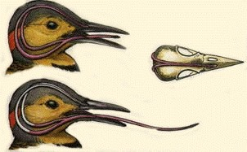

**Oral glands** ­ secrete a variety of substances including: saliva

Lubrication and binding: the mucus in saliva is extremely effective in binding masticated food into a slippery bolus that (usually) slides easily through the esophagus without inflicting damage to the mucosa. Saliva also coats the oral cavity and esophagus, and food basically never directly touches the epithelial cells of those tissues.

Solubilizes dry food: in order to be tasted (by taste buds), the molecules in food must be solubilized.

Oral hygiene: The oral cavity is almost constantly flushed with saliva, which floats away food debris and keeps the mouth relatively clean. Saliva also contains lysozyme, an enzyme that lyses many bacteria and prevents overgrowth of oral microbial populations.

Initiates starch digestion: in most species, amylase is present in saliva and begins to digest dietary starch into maltose. Amylase does not occur in the saliva of carnivores.

Provides alkaline buffering and fluid: this is of great importance in ruminants, which have non­ secretory forestomachs.

Evaporative cooling: clearly of importance in dogs, which have very poorly developed sweat glands ­ look at a dog panting after a long run and this function will be clear.

poison ([lizards](http://wc.pima.edu/Bfiero/tucsonecology/animals/rept_gimo.htm), [snakes](http://reptilis.net/serpentes/venom.html), and [mammals](http://pubs.acs.org/cen/critter/8242shrews.html)) anticoagulant ([vampire bats](http://www.pitt.edu/AFShome/s/l/slavic/public/html/courses/vampires/images/bats/vambat.html); [video](http://www.nationalgeographic.com/kids/creature_feature/0110/vampirebats.html))

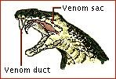

**Pharynx** ­ part of digestive tract exhibiting pharyngeal pouches (at least in the embryo) that may give rise to slits

Fish ­ pharynx is respiratory organ Tetrapods:

pharynx is the part of the foregut preceeding the esophagus & includes: glottis (slit leading into the larynx)

openings of auditory (eustachian) tubes opening into esophagus

Mammals ­ an epiglottis is positioned over the glottis so that, when a mammal swallows, the larynx is drawn forward against the epiglottis & the epiglottis blocks the glottis (which prevents food or liquids from entering the trachea)

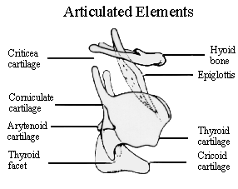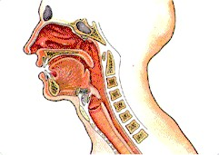

# Esophagus:

Source: <http://www.stroke.cwc.net/niweb/faq.htm>

a distensible [muscular tube](http://www.westga.edu/~lkral/peristalsis/index.html) connecting the pharynx & the stomach may have diverticulum called the crop (see diagram of pigeon below)

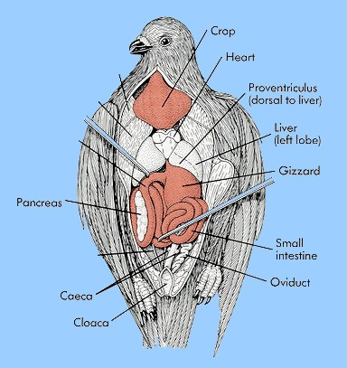

**Stomach** = muscular chamber(s) at end of esophagus

serves as storage & macerating site for ingested solids & secretes digestive enzymes Vertebrate stomachs:

Cyclostomes ­ weakly developed; similar to esophagus

[Fish](http://www.uwinnipeg.ca/~simmons/fish8.htm), amphibians, & reptiles ­ increasing specialization (more differentiated from the esophagus) Birds ­ proventriculus (glandular stomach) and ventriculus (muscular stomach, or gizzard)

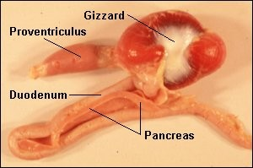

Mammals ­ well­developed [stomach](http://www.bbc.co.uk/science/humanbody/body/factfiles/skeletalsmoothandcardiac/stomach_peristalsis.shtml); [ruminants](http://arbl.cvmbs.colostate.edu/hbooks/pathphys/digestion/herbivores/rumination.html) have multichambered stomachs:

**Reticulo­rumen (reticulum and rumen)**

Reticulum and rumen are often discussed together since each compartment is separated by a low partition. Eighty percent of the capacity of the stomach is related to the reticulo­rumen. The contents of the reticulum and rumen intermix freely. The rumen is the main fermentation vat where billions of microorganisms attack and break down the relatively indigestible feed components of the ruminant's diet.

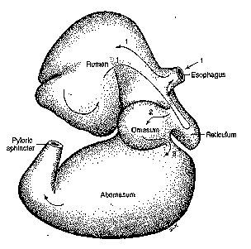

Source: <http://www.uta.edu/biology/restricted/3452dig.htm>

**Omasum**

After fermentation in the reticulum and rumen, food passes to the omasum. The omasum acts as a filter pump to sort liquid and fine food particles. Coarse fibre particles are not allowed to enter the omasum. Also, the omasum may be the site for absorption of water, minerals and nitrogen.

**Abomasum**

The abomasum is the true stomach and the only site on the digestive tract that produces gastric juices (HCl and the enzymes, pepsin and rennin). Ingesta only remains here for 1 to 2 hours.

The **intestine** is located between the stomach & the cloaca or anus & is an important site for digestion & absorption. Vertebrate intestines are differentiated to varying degrees into small & large intestines.

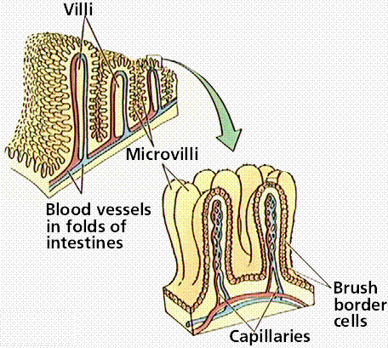

Fishes ­ relatively straight & short intestine in cartilaginous fishes & in primitive bony fishes (lungfish & sturgeon). However, the intestine of cartilaginous fishes has a spiral valve.

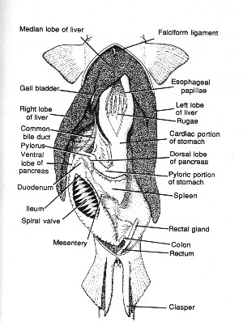

Amphibians ­ intestines differentiated into coiled small intestine and short, straight large intestine Reptiles & Birds ­ coiled small intestines & a relatively short large intestine (that empties into the cloaca)

Mammals ­ [small intestine](http://staff.francisparker.org/DJohnson/new%20stuff%20htm/physiology/animations/digestionsmall%20intestine.ram) long & coiled and differentiated into duodenum, jejunum, & ileum. The large intestine is often relatively long (but not as long as the small intestine). A cecum is often present at the junction of the small & large intestines in herbivores.

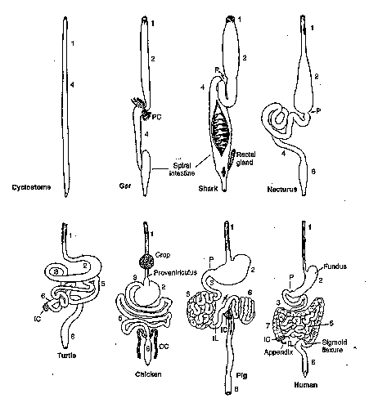

Source: <http://www.uta.edu/biology/restricted/3452dig.htm>

**Accessory organs** ­ Liver, gall bladder, & pancreas Liver & gall bladder

liver produces bile which is stored in the gall bladder (cyclostomes, most birds, and some

mammals, including cervids, have no gall bladder)

bile aids in digestion by emulsifying fats (breaking fats down into tiny particles that permits more efficient digestion by enzymes)

Pancreas ­ secretes pancreatic juice (bicarbonate solution to neutralize acids coming from the stomach plus enzymes to help digest carbohydrates, fats, and proteins) into the intestine

**Ceca** ­ blind diverticula that serve to increase the surface area of the vertebrate digestive tract

Fishes ­ [pyloric](http://www.hedley.ca/anatomy_internal.html) & duodenal ceca are common in teleosts; these are primary areas for digestion and absorption (not fermentation chambers)

Tetrapods ­ ceca are present in some herbivores; may contain bacteria that aid in the digestion of cellulose

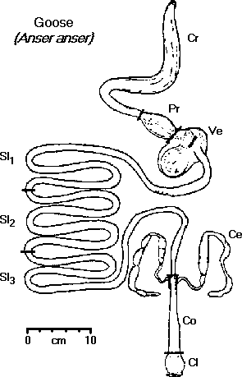

# Cloaca:

chamber at end of digestive tract that receives the intestine, & urinary & genital ducts, & opens to the exterior via the vent

shallow or non­existent in lampreys, ray­finned fishes, & mammals (except monotremes) if no cloaca is present, the intestine opens directly to the exterior via anus

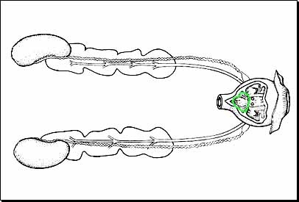

Source: <http://trc.ucdavis.edu/mjguinan/apc100/modules/Reproductive/bird/male0/male10.html>